Good News Friday's Edition 23
Franklin Early Childhood Center
Exciting news at Franklin this week…all families of our current kindergarten students received notice that their child was placed in their first place school choice for the 2024-25 school year! With this marvelous news to share we were excited to send the individual letters from Interim Superintendent John Macero to our 31 Franklin kindergarten families on Wednesday, February 28th, two days ahead of schedule.  With these placements complete and kindergarten registration well underway the next District Wide placement process will be for students heading to kindergarten. Much like the first grade placement process the kindergarten placement process follows the criteria for Elementary School Assignment Policy set by the Melrose School Committee:  The Committee does not recognize any neighborhood boundaries or neutral zones but does recognize that elementary schools are not evenly spaced throughout the district. Families are able to choose 3 of our 5 Elementary Schools.  Criteria for determining school assignment is based on the following factors, with consideration given to yearly enrollment numbers as well as each unique student cohort:  - Need for special programs and/or facilities including, but not limited to, English Language Learning and special education  - Equity of class size across the district by grade level  - Timeliness of Survey (on-time vs late)  - Family preference including presence of siblings in the school  - Proximity of the child(ren)’s residence to the preferred school(s) and proximity of the child(ren)’s residence to each of the elementary schools  Now that current kindergarten student placements have been finalized the behind the scenes work of preparing for the students’ transition to a new school has begun. Here are just a few of the important transition activities that will happen in the coming months:  - PTO representatives from the elementary schools will reach out to welcome incoming families and or Franklin families may choose to attend a PTO | meeting to get to know families in their new  school  - School personnel, including teachers and administrators from each school will be coming to Franklin to meet our amazing Franklin kindergarten foxes  - Middle of the Year and End of the Year kindergarten assessment data team meetings will happen at Franklin. District wide staff will join these meetings to be sure our Franklin students are ready for the upcoming transition to a new school and the new schools are ready for our students.  - Current and receiving administrators and faculty will work collaboratively to share recommendations for class placement at each school. The class placements will be shared with families sometime in August.  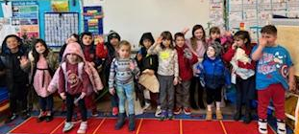  While they still have a few more months with us here at Franklin, we are excited to begin to think about each Franklin Fox officially becoming a Horace Mann Husky, Hoover Hawk, Lincoln Lion, Roosevelt Raven or a Winthrop Wildcat! We promise though to continue to do everything we can to ensure our kindergarten Franklin foxes are ready for the big move to a new school for the 2024-25 school year!.

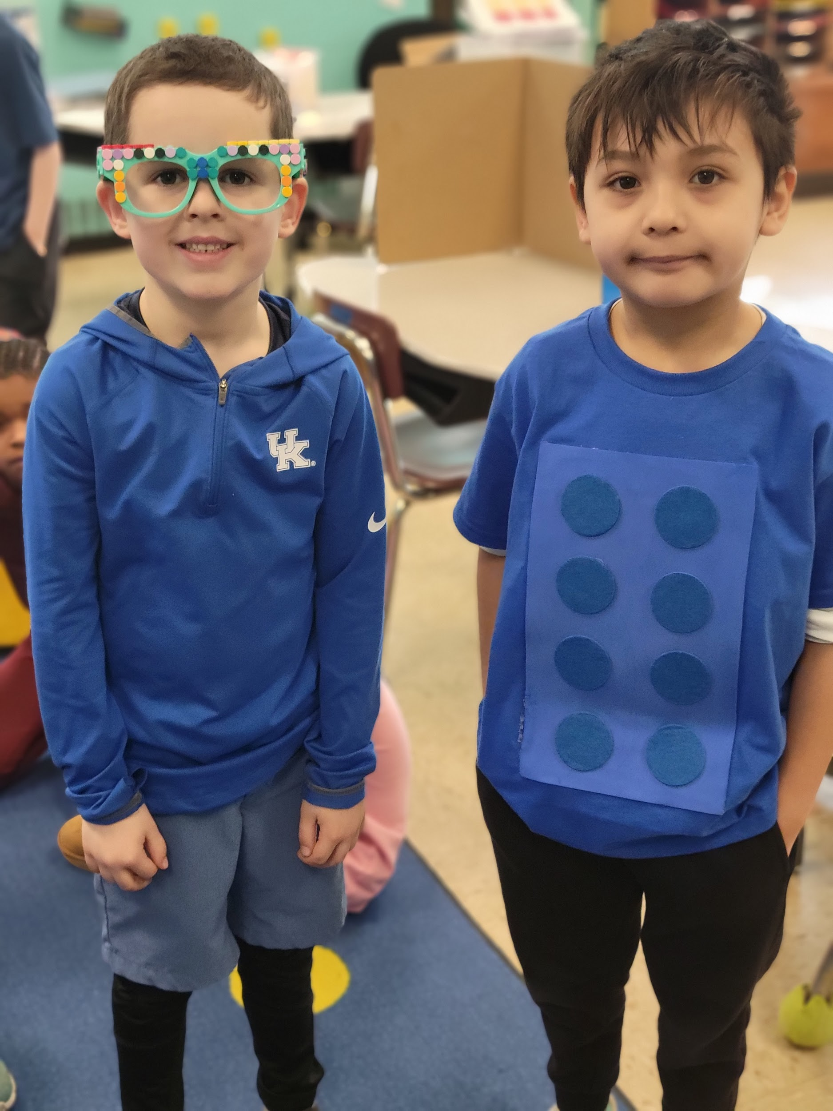
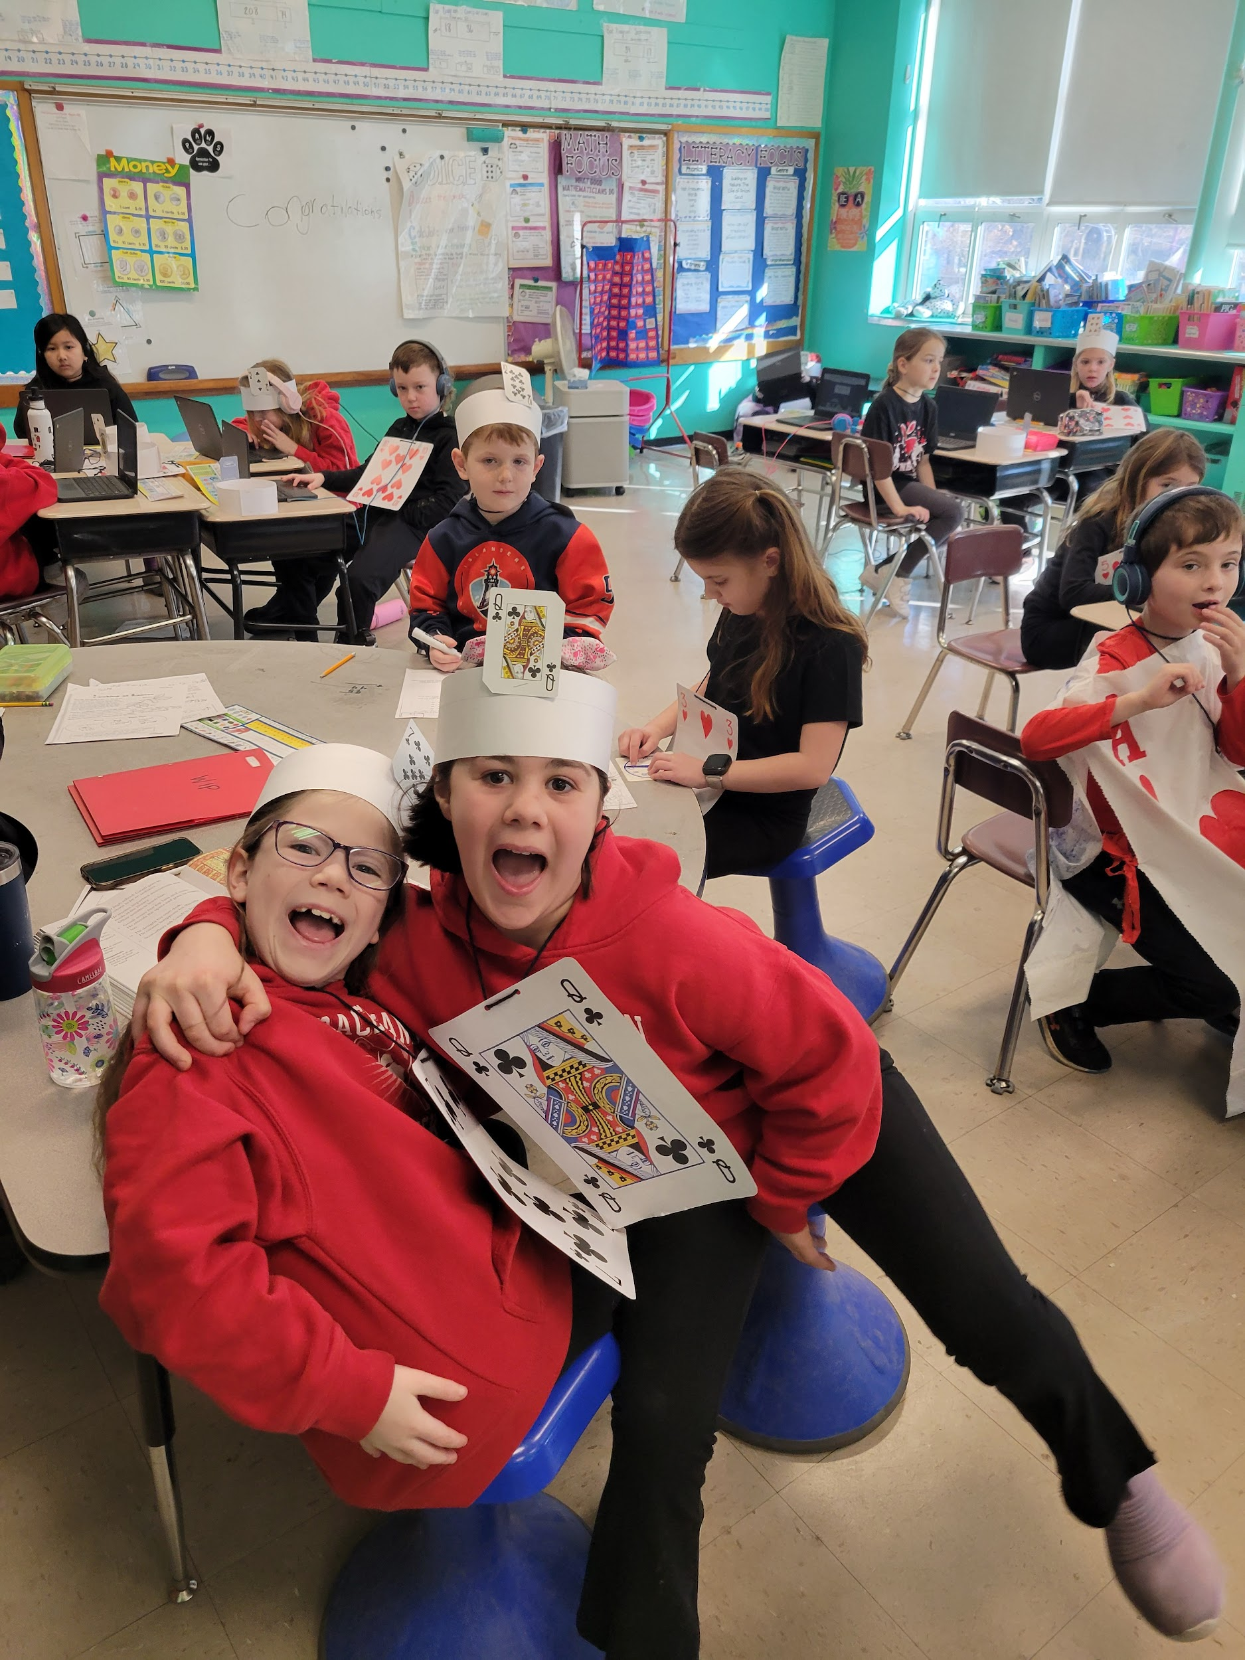
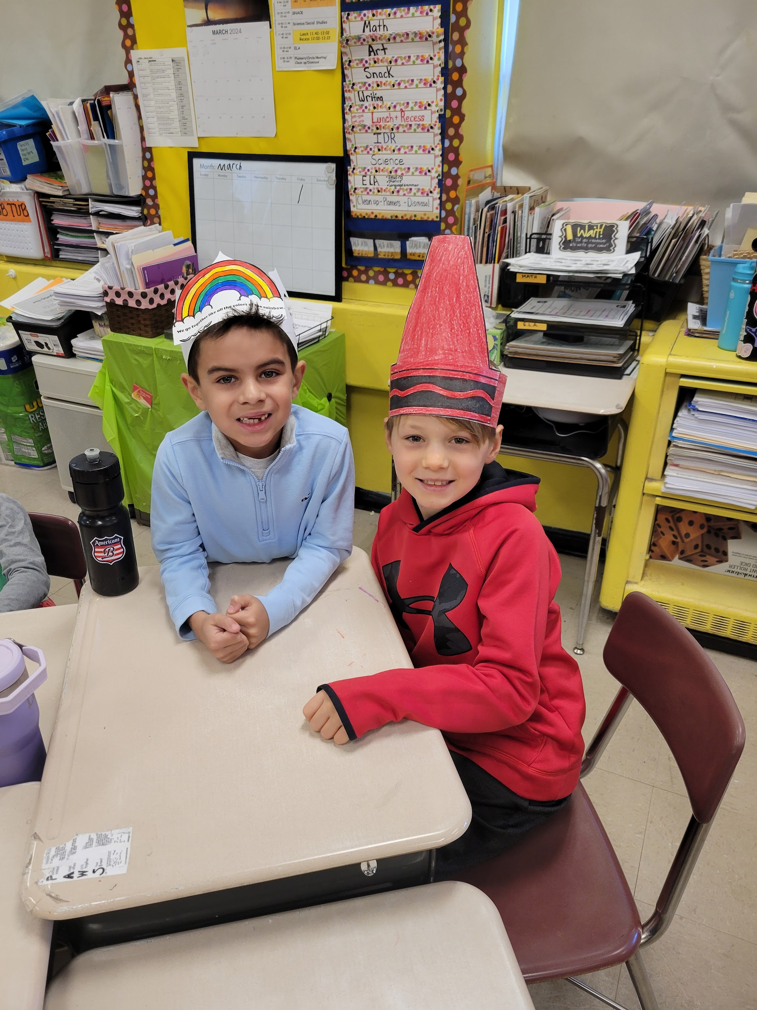
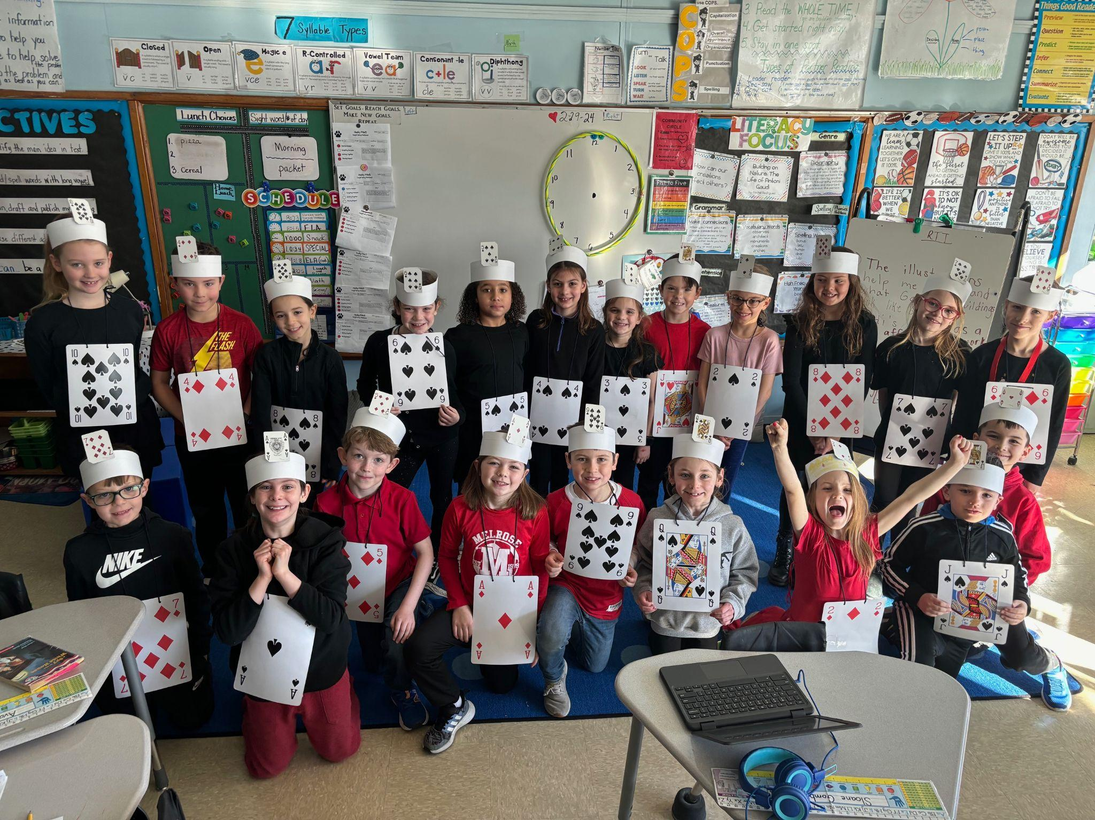

Horace Mann School
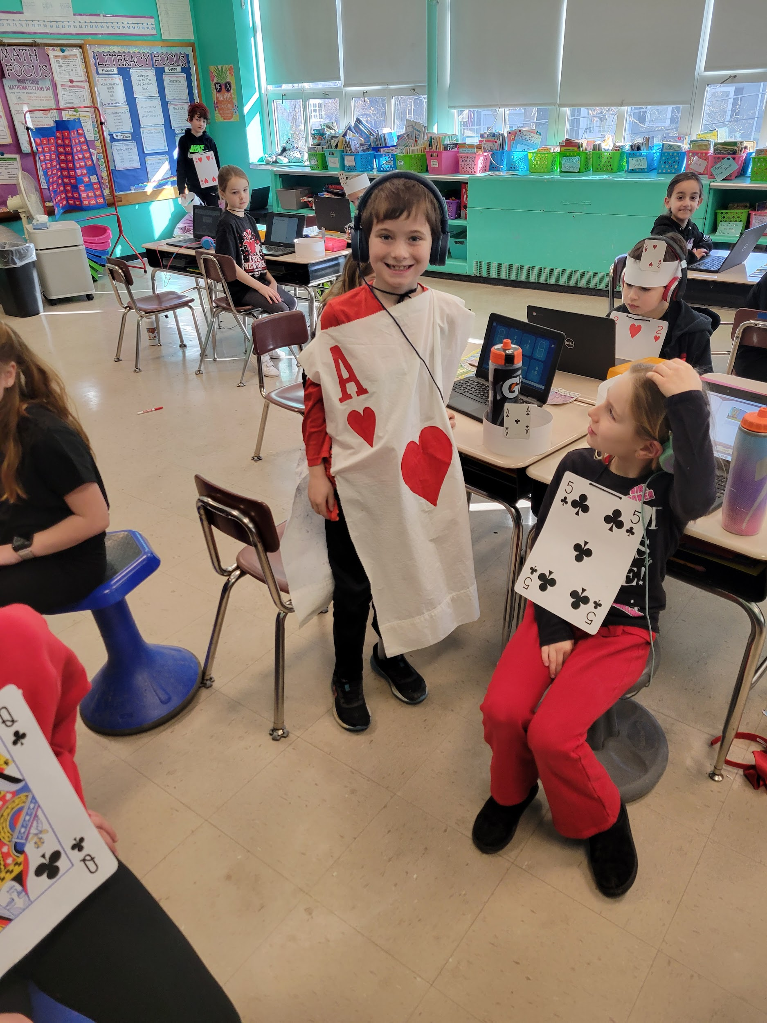
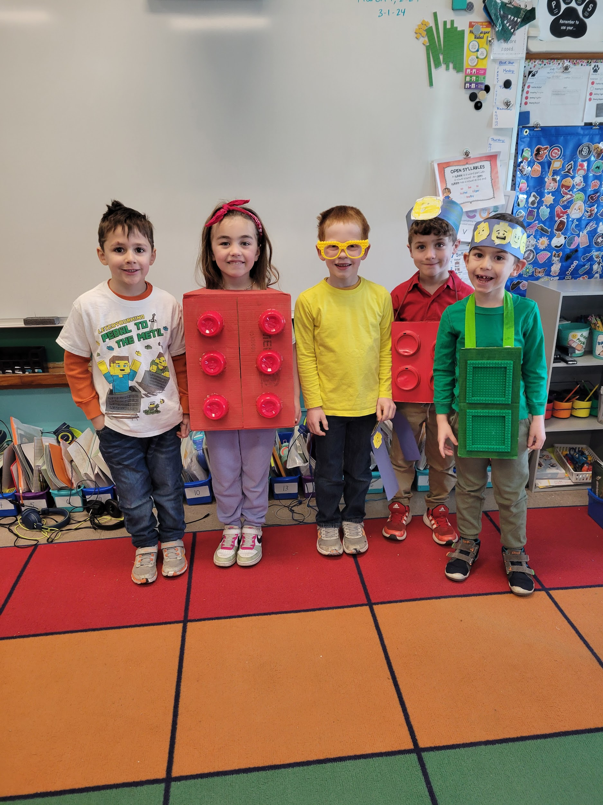
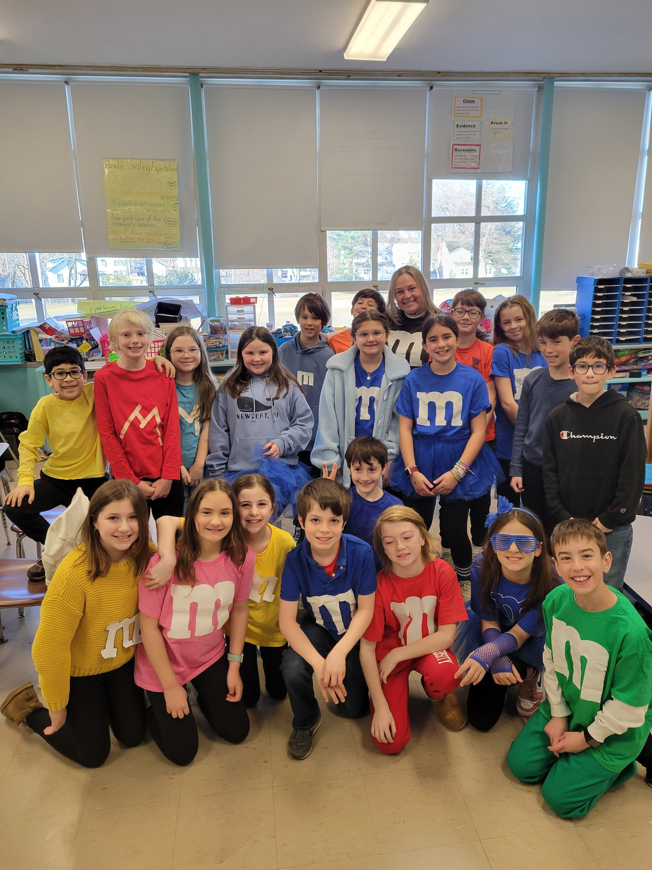
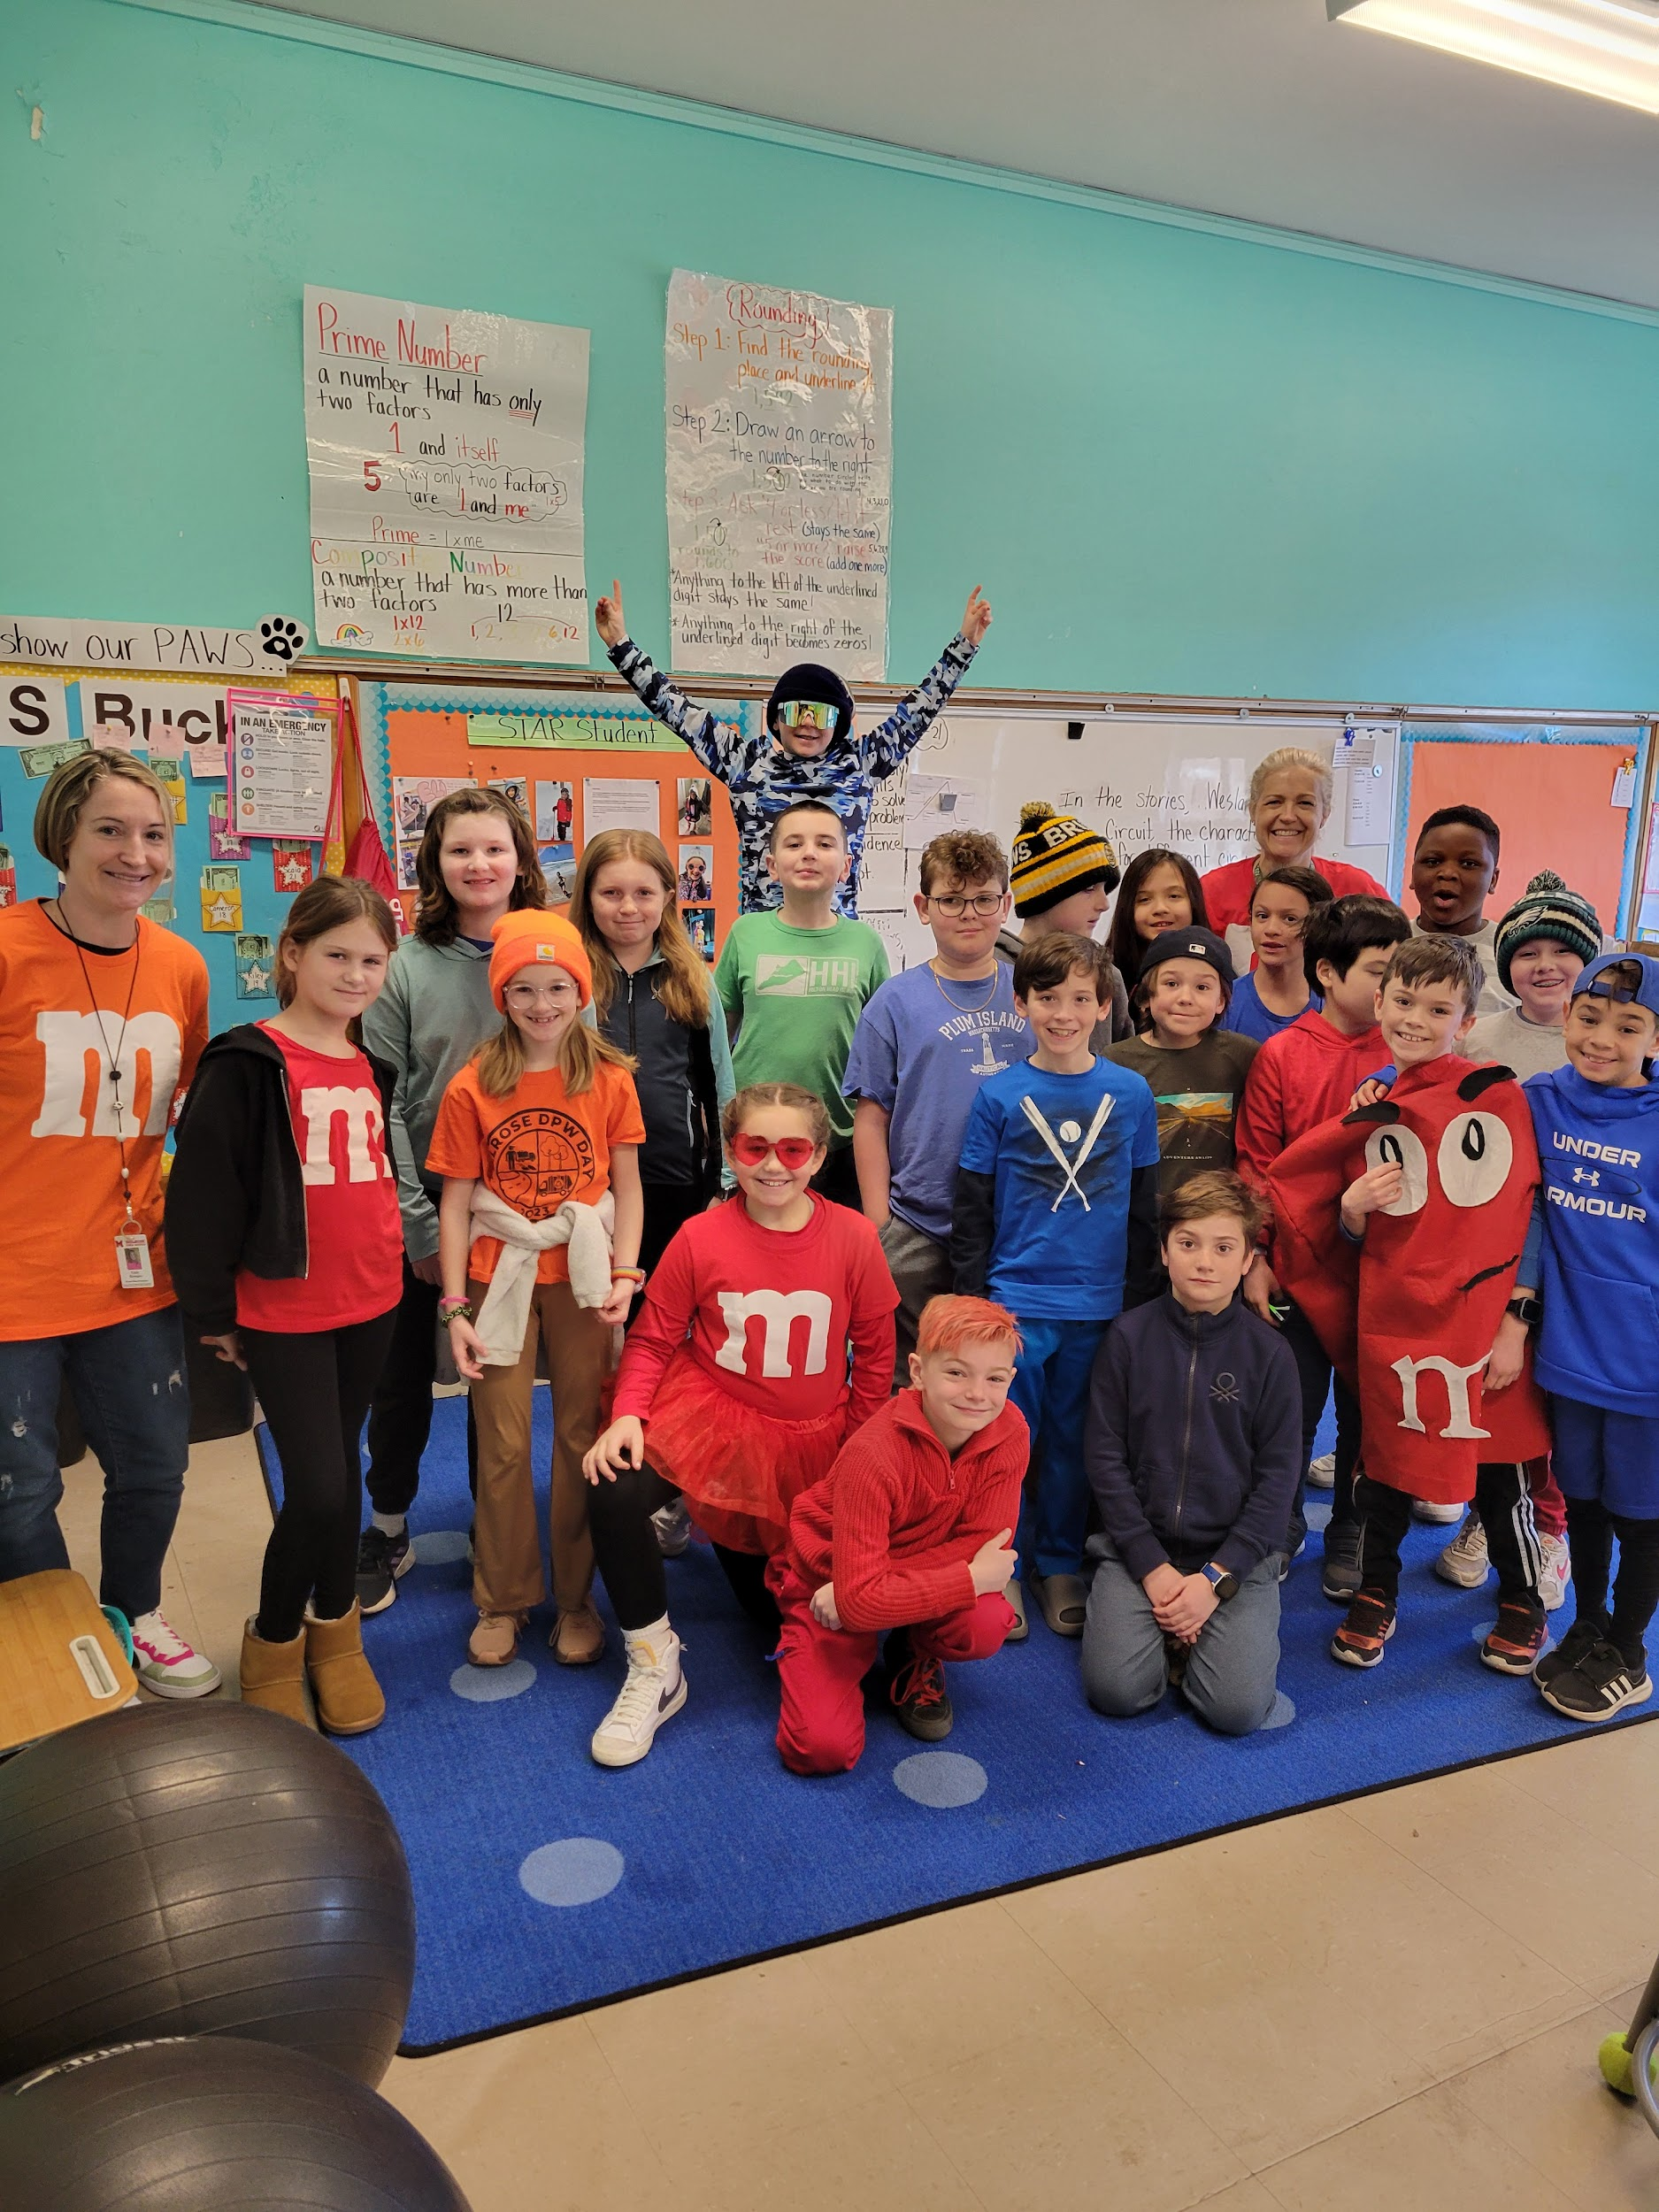
Friday, March 1st is Spirit Day at Horace Mann. This was the result of our students earning over 1000 Husky PAWS coins. The theme of our day is “We go together like…” Each grade level completed this simile with an idea that honors the ways we are alike and celebrates our differences.
Kindergarten goes together like the colors in a rainbow.
Grade 1 goes together like legos.
Grade 2 goes together like a deck of cards.
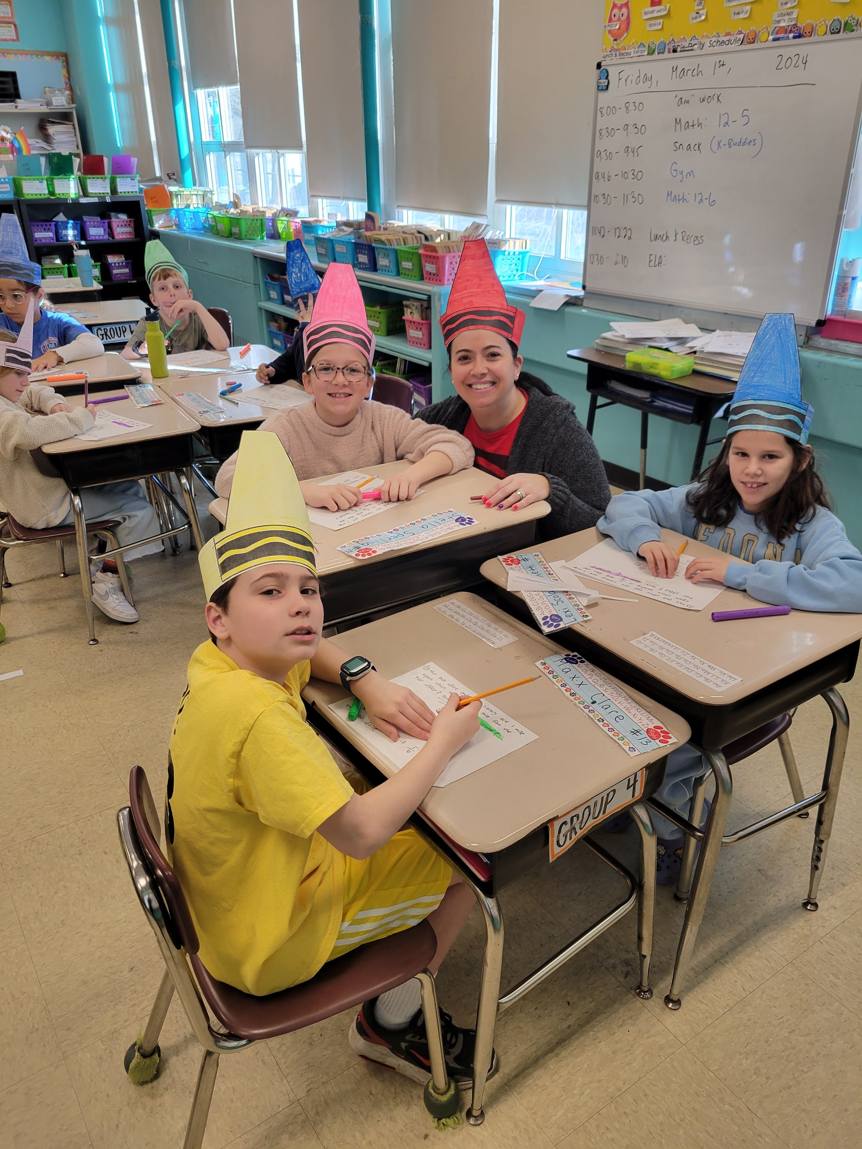
Grade 3 goes together like a box of Crayons.
Grade 4 goes together like M&M’s.
Grade 5 goes together like night and day.
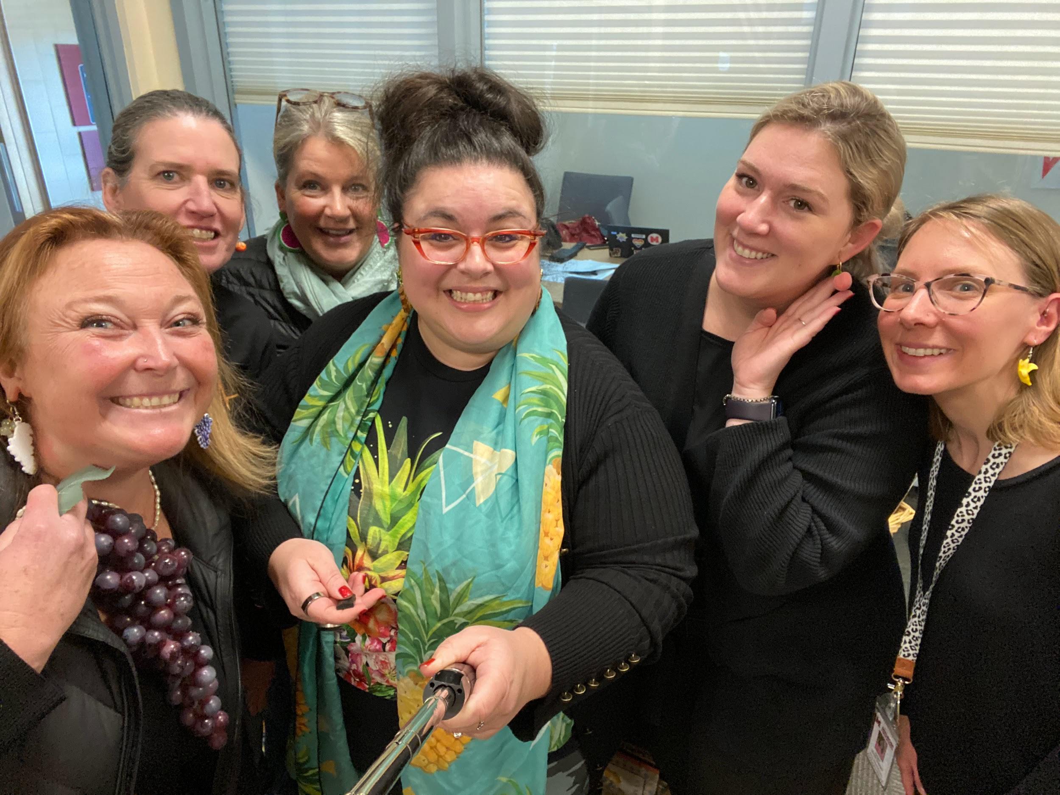
Even the office staff joined in the fun as fruit salad!
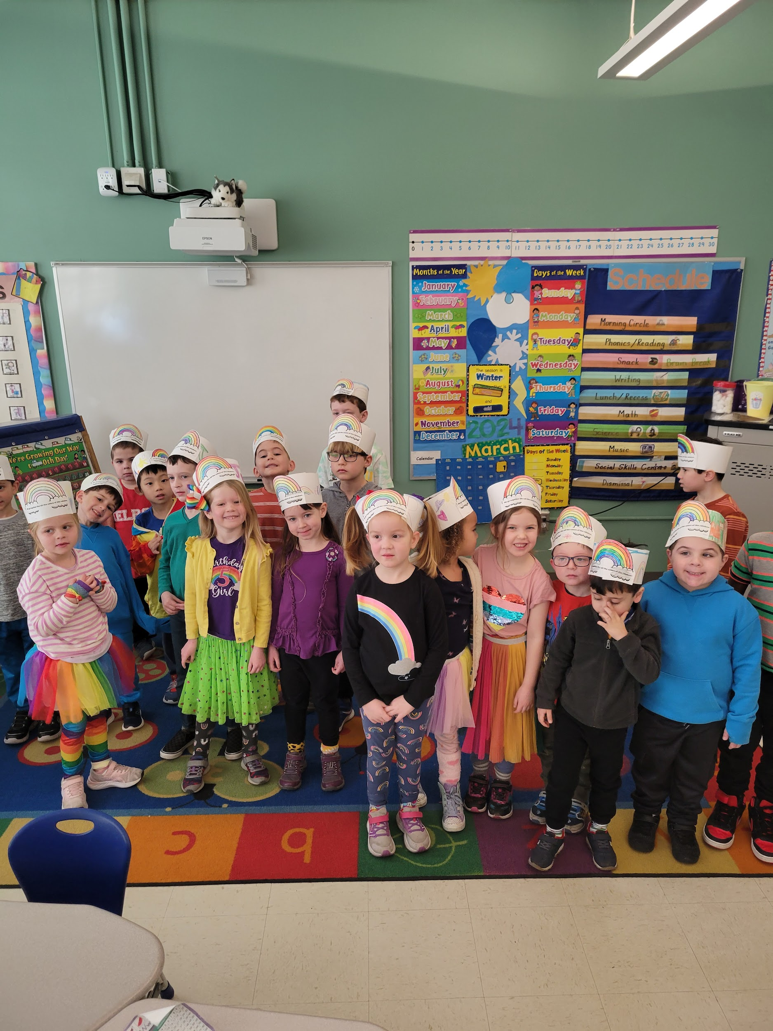
As a proud pack, we know the importance of belonging. At Horace Mann belonging means having a space where you fit in and can be seen for your whole, wonderful, true self. That is certainly something to celebrate.
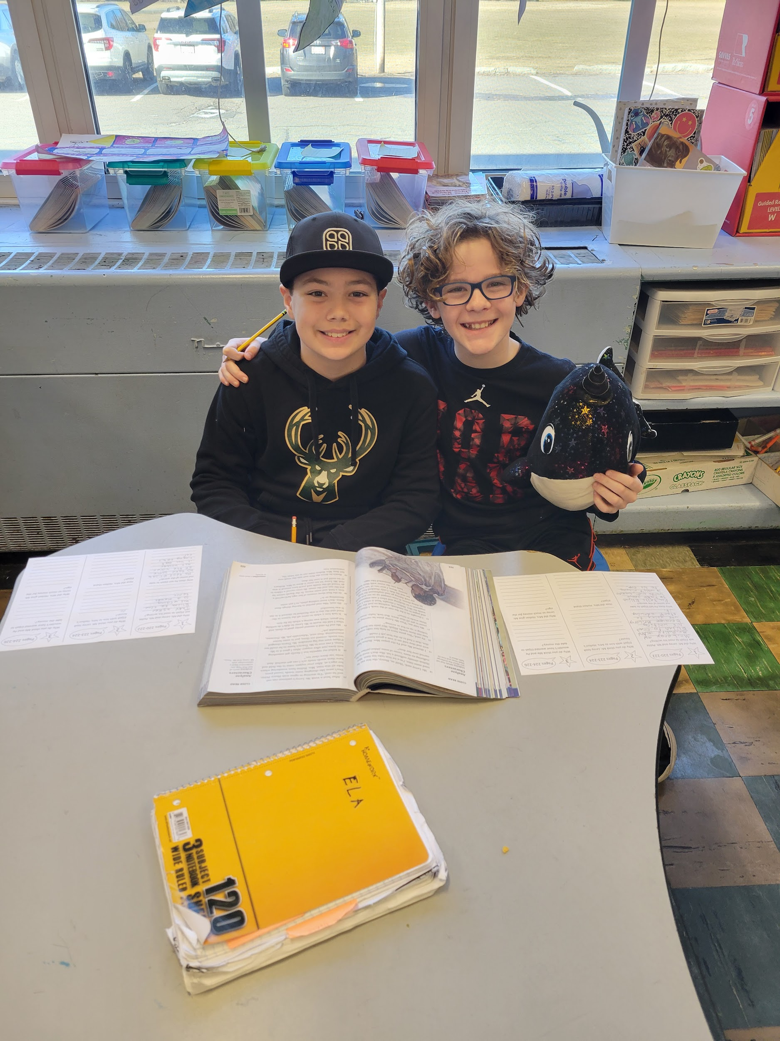
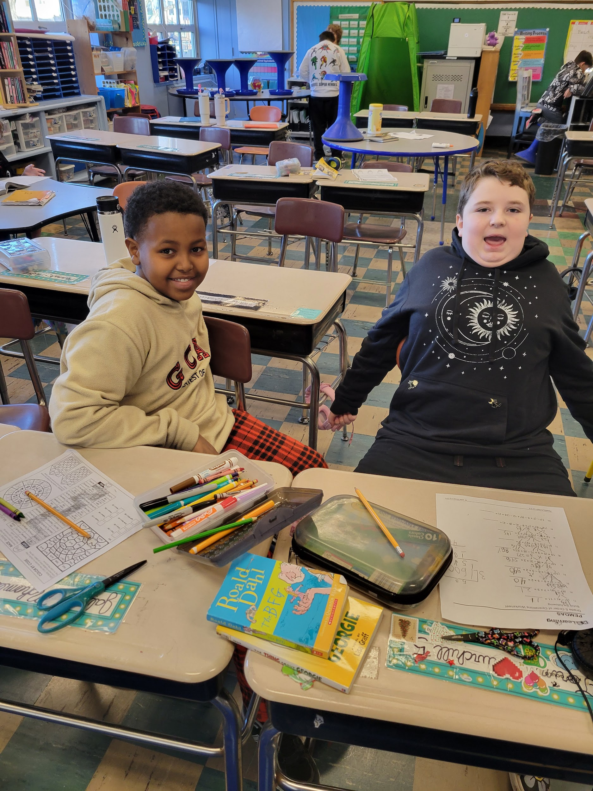
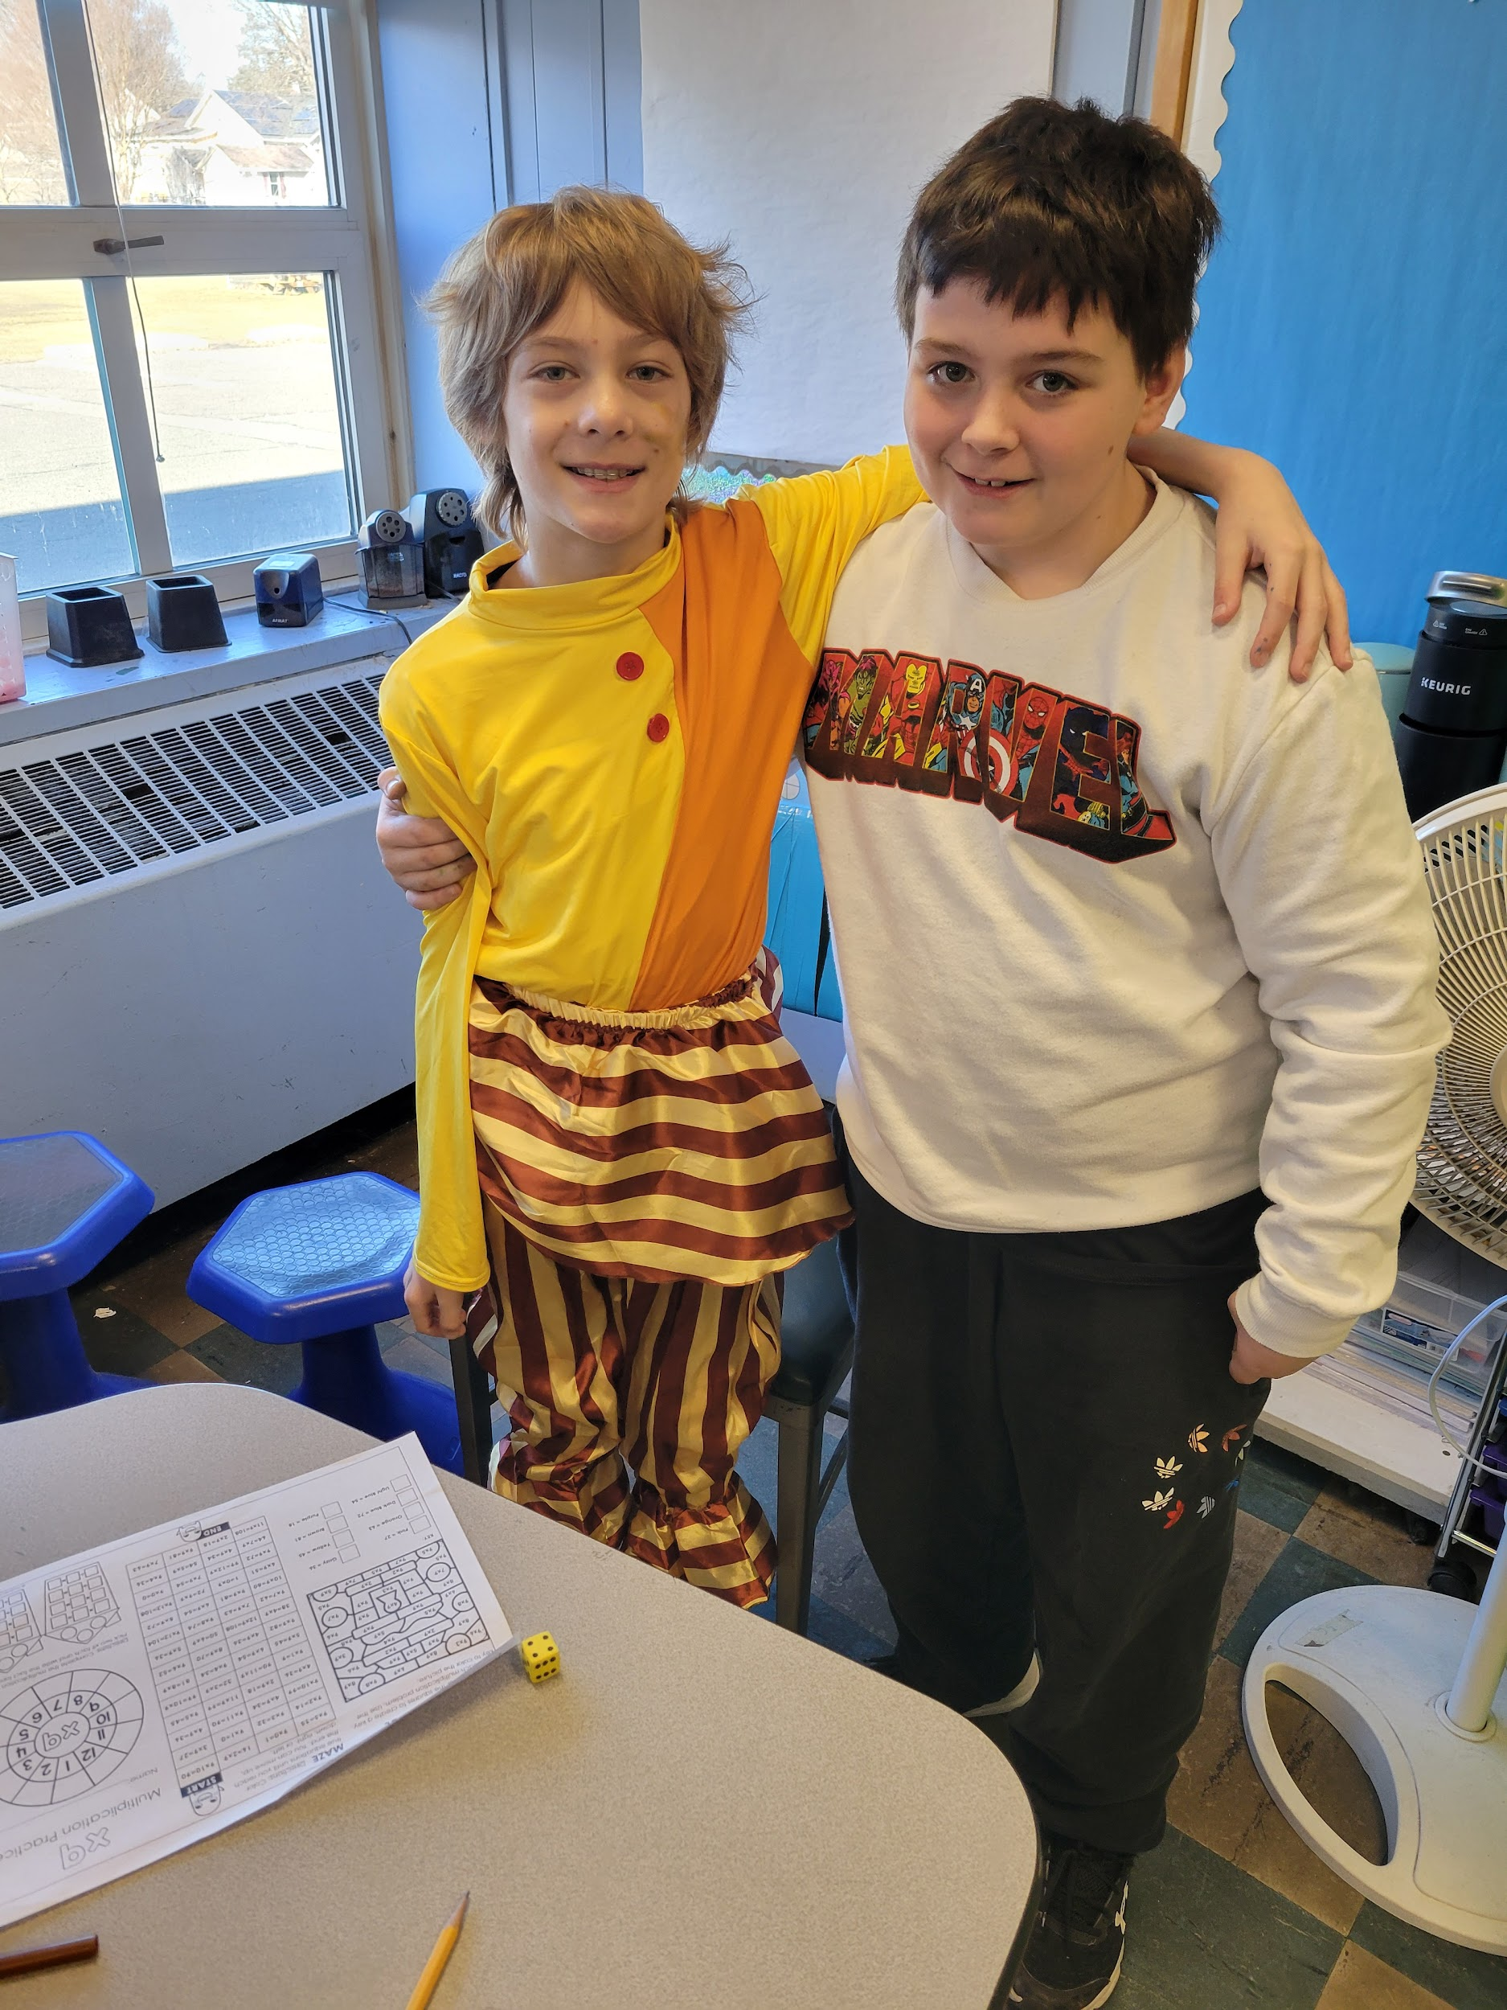
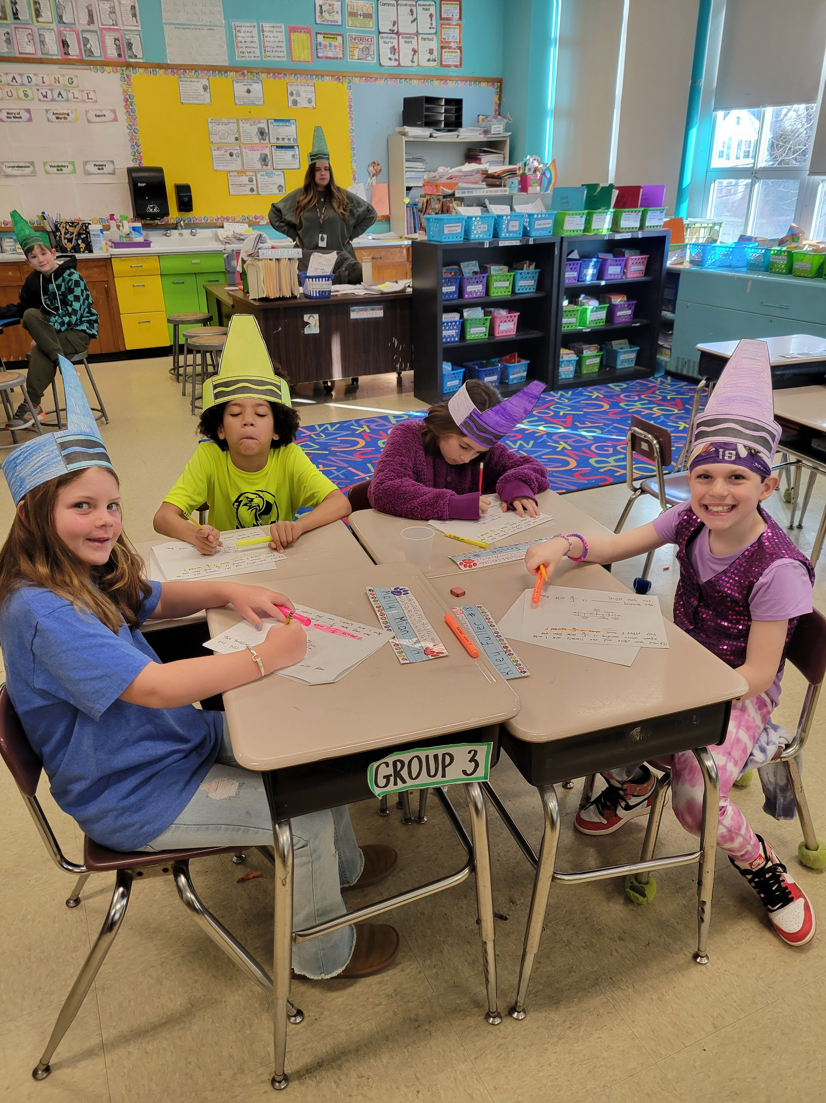
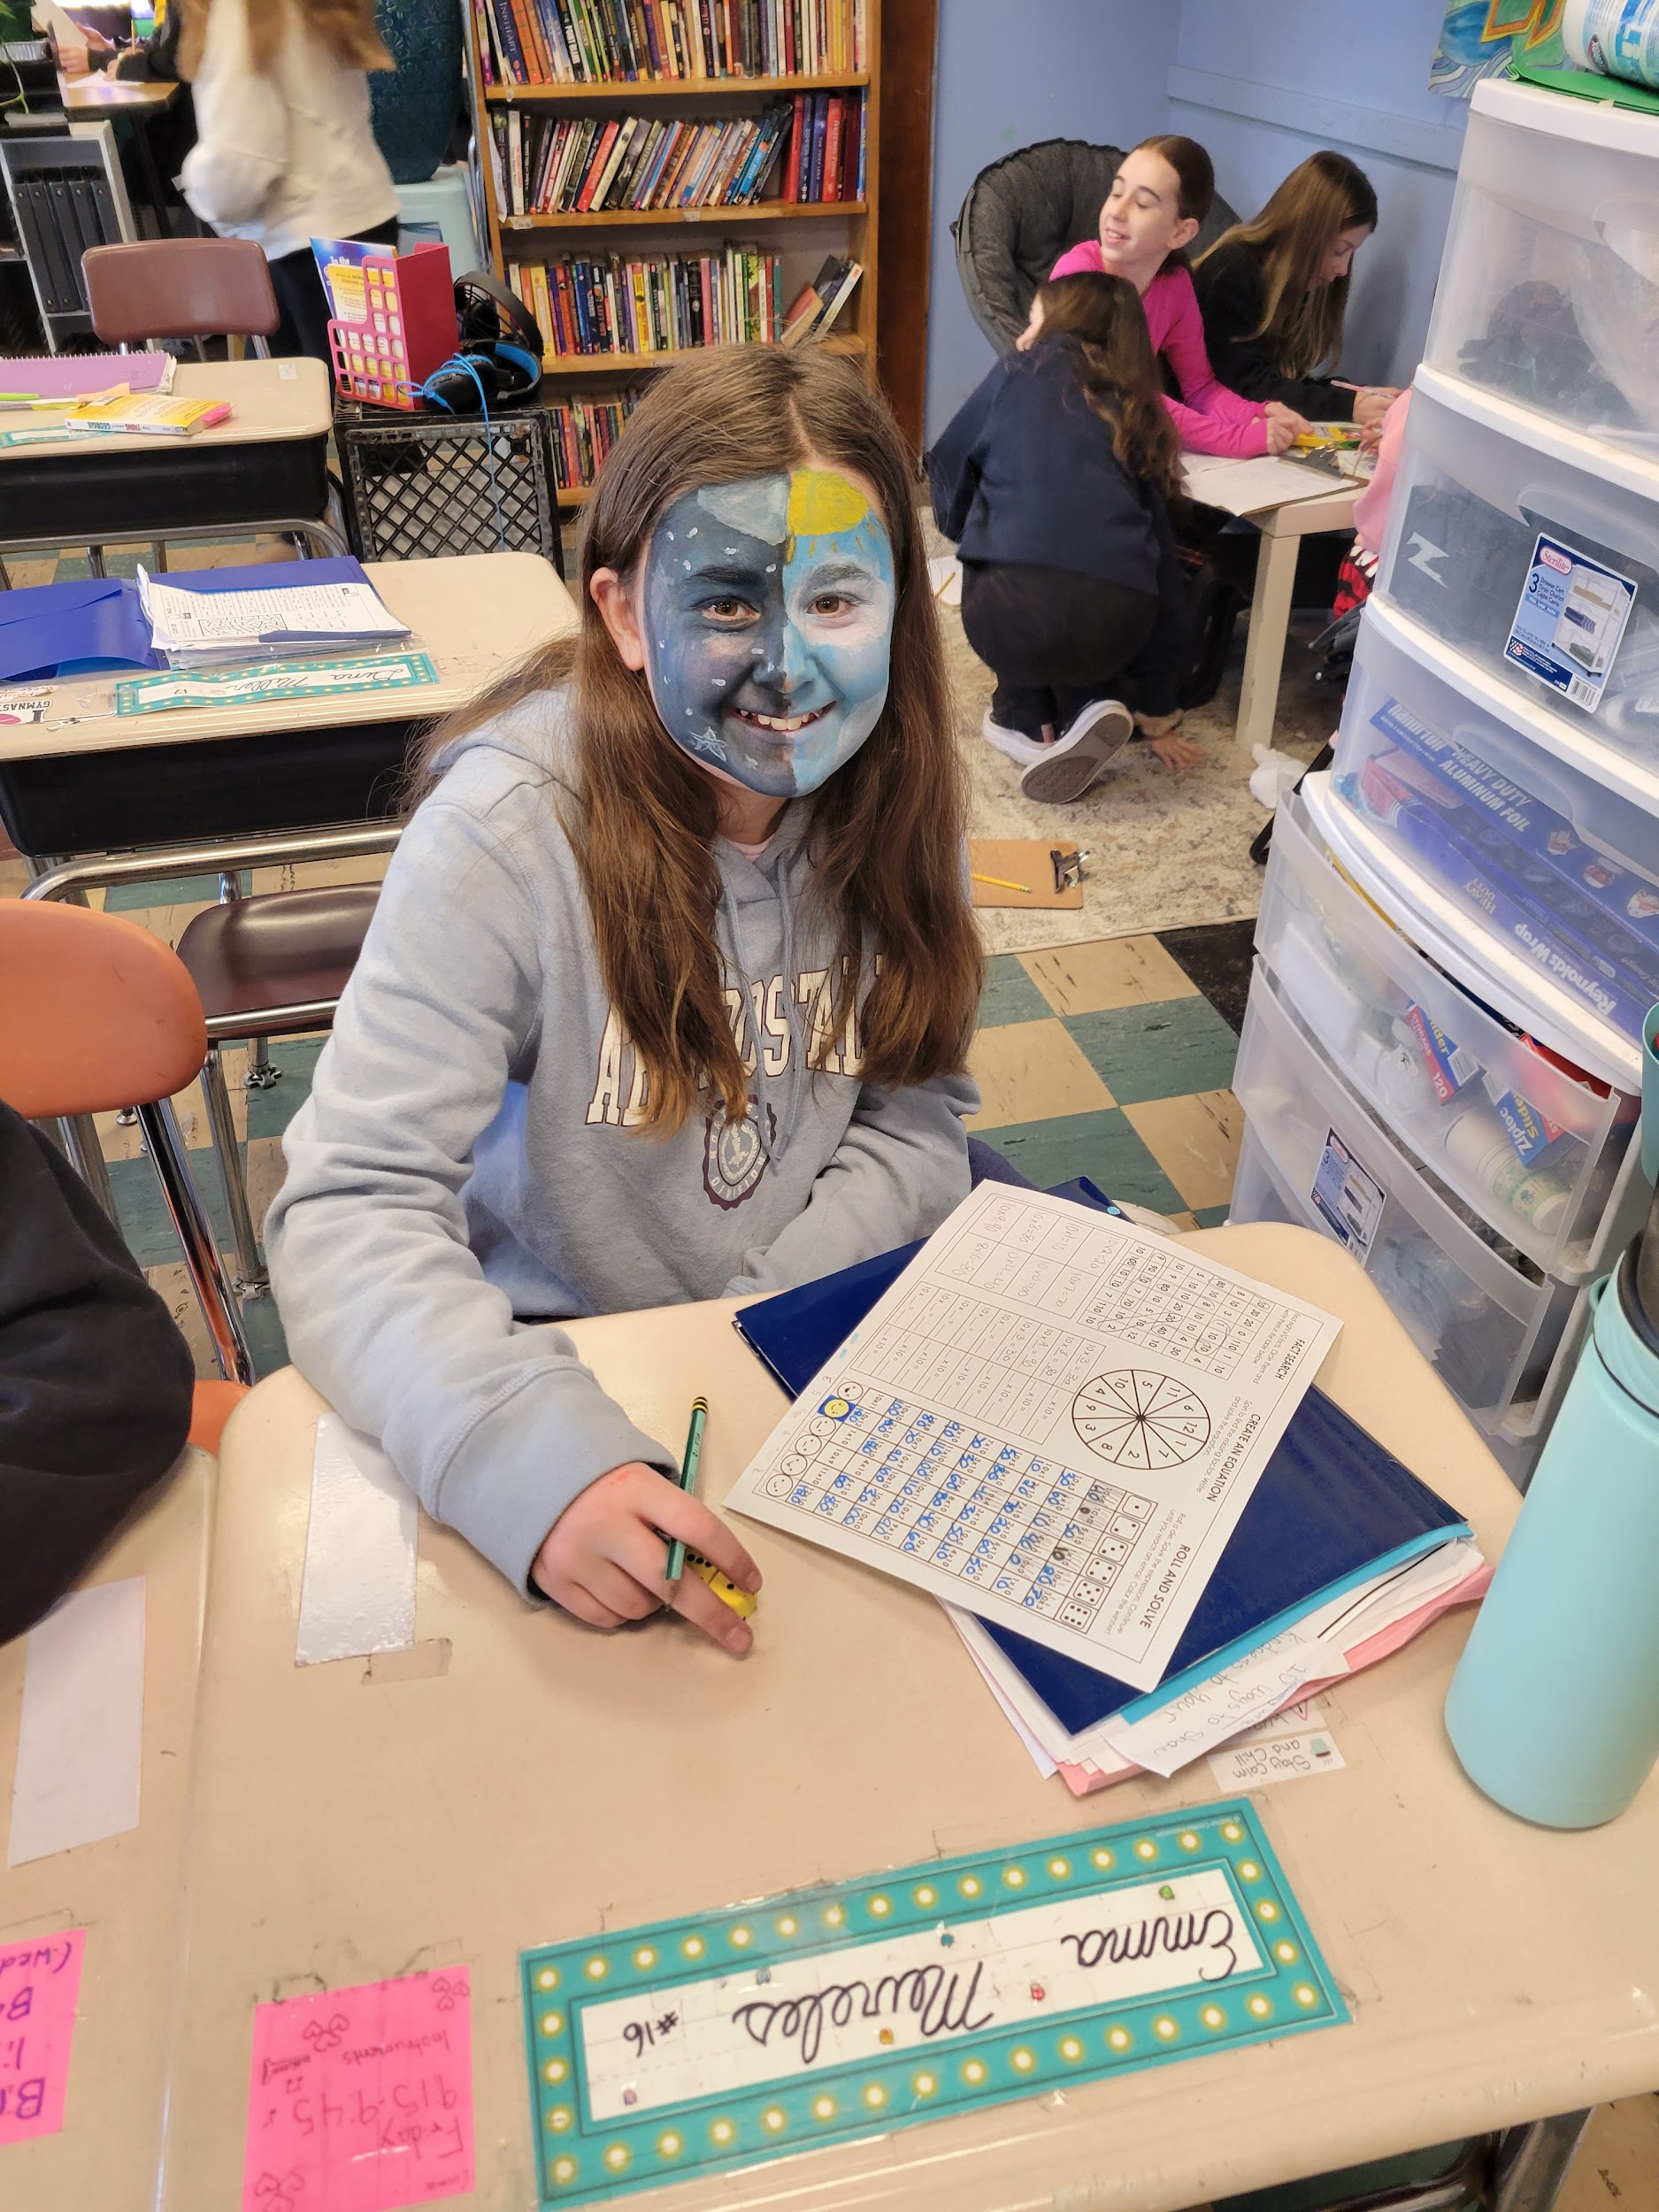

Hoover School
The fourth graders at Hoover are learning about electricity this month. They have learned how to build different types of circuits following the inquiry method. So much fun!
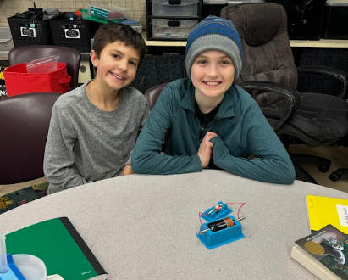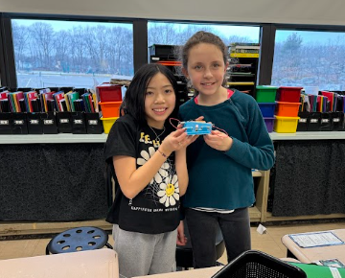

The fourth grade has also been competing in a grade-wide Geometry Vocabulary Challenge this year. They have worked cooperatively as a grade, as a class and competed as well.
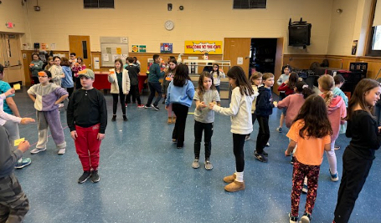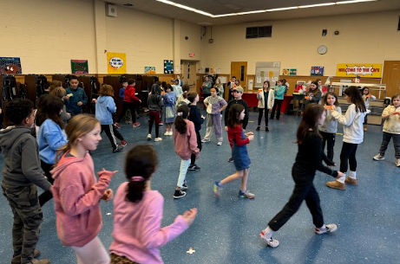

Lincoln School

Lincoln School is celebrating literacy today with a “Dress as your Favorite Book Character” day! School spirit is evident all over the school! We were lucky enough to get a glimpse of Pete the Cat (and Re-Pete the cat!), Belle, Elephant and Piggie and more!!!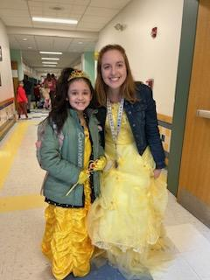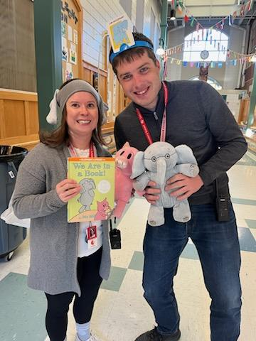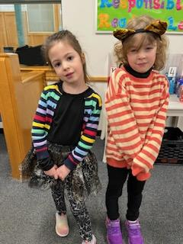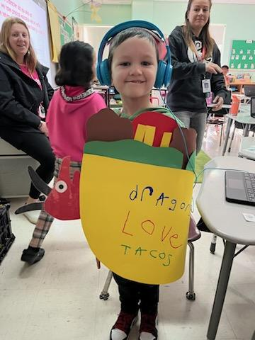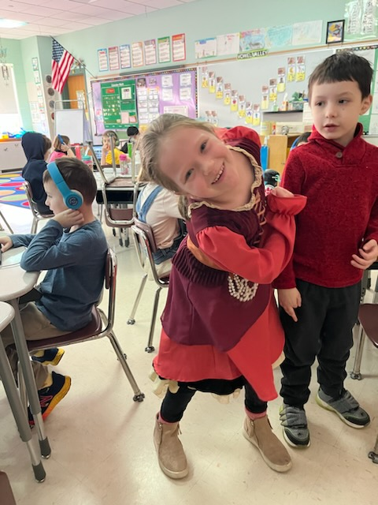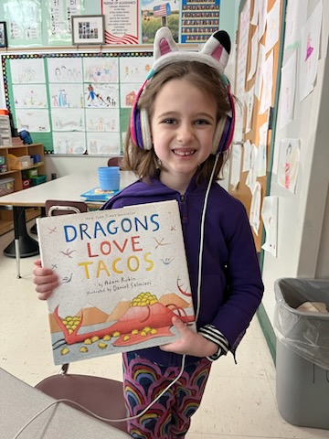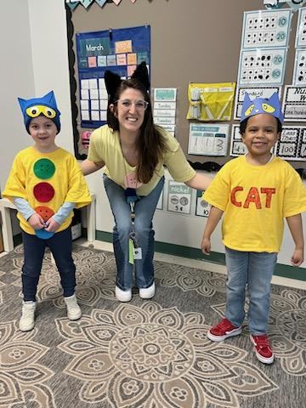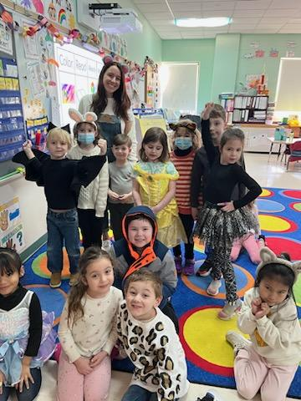

Roosevelt School:

Dmitra Mukasa visited Roosevelt School. She is a Melrose High School Senior and as her Capstone project she and some of her classmates came to our grade 2 students and presented about the STEM field.

Many girls aren't introduced to the STEM field until High School. Part of her capstone project is to inform girls as early as elementary school so it might garner more interest and maybe propel more girls into the STEM field. Data shows that only 28% of the STEM field is women, and girls lose confidence in math by third grade compared to boys who say they are good in math by second grade. The students loved her presentation.
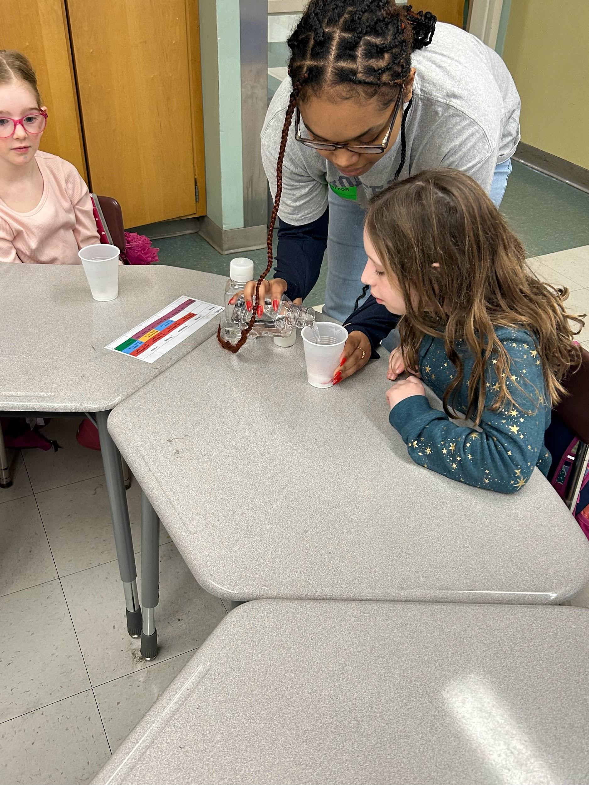
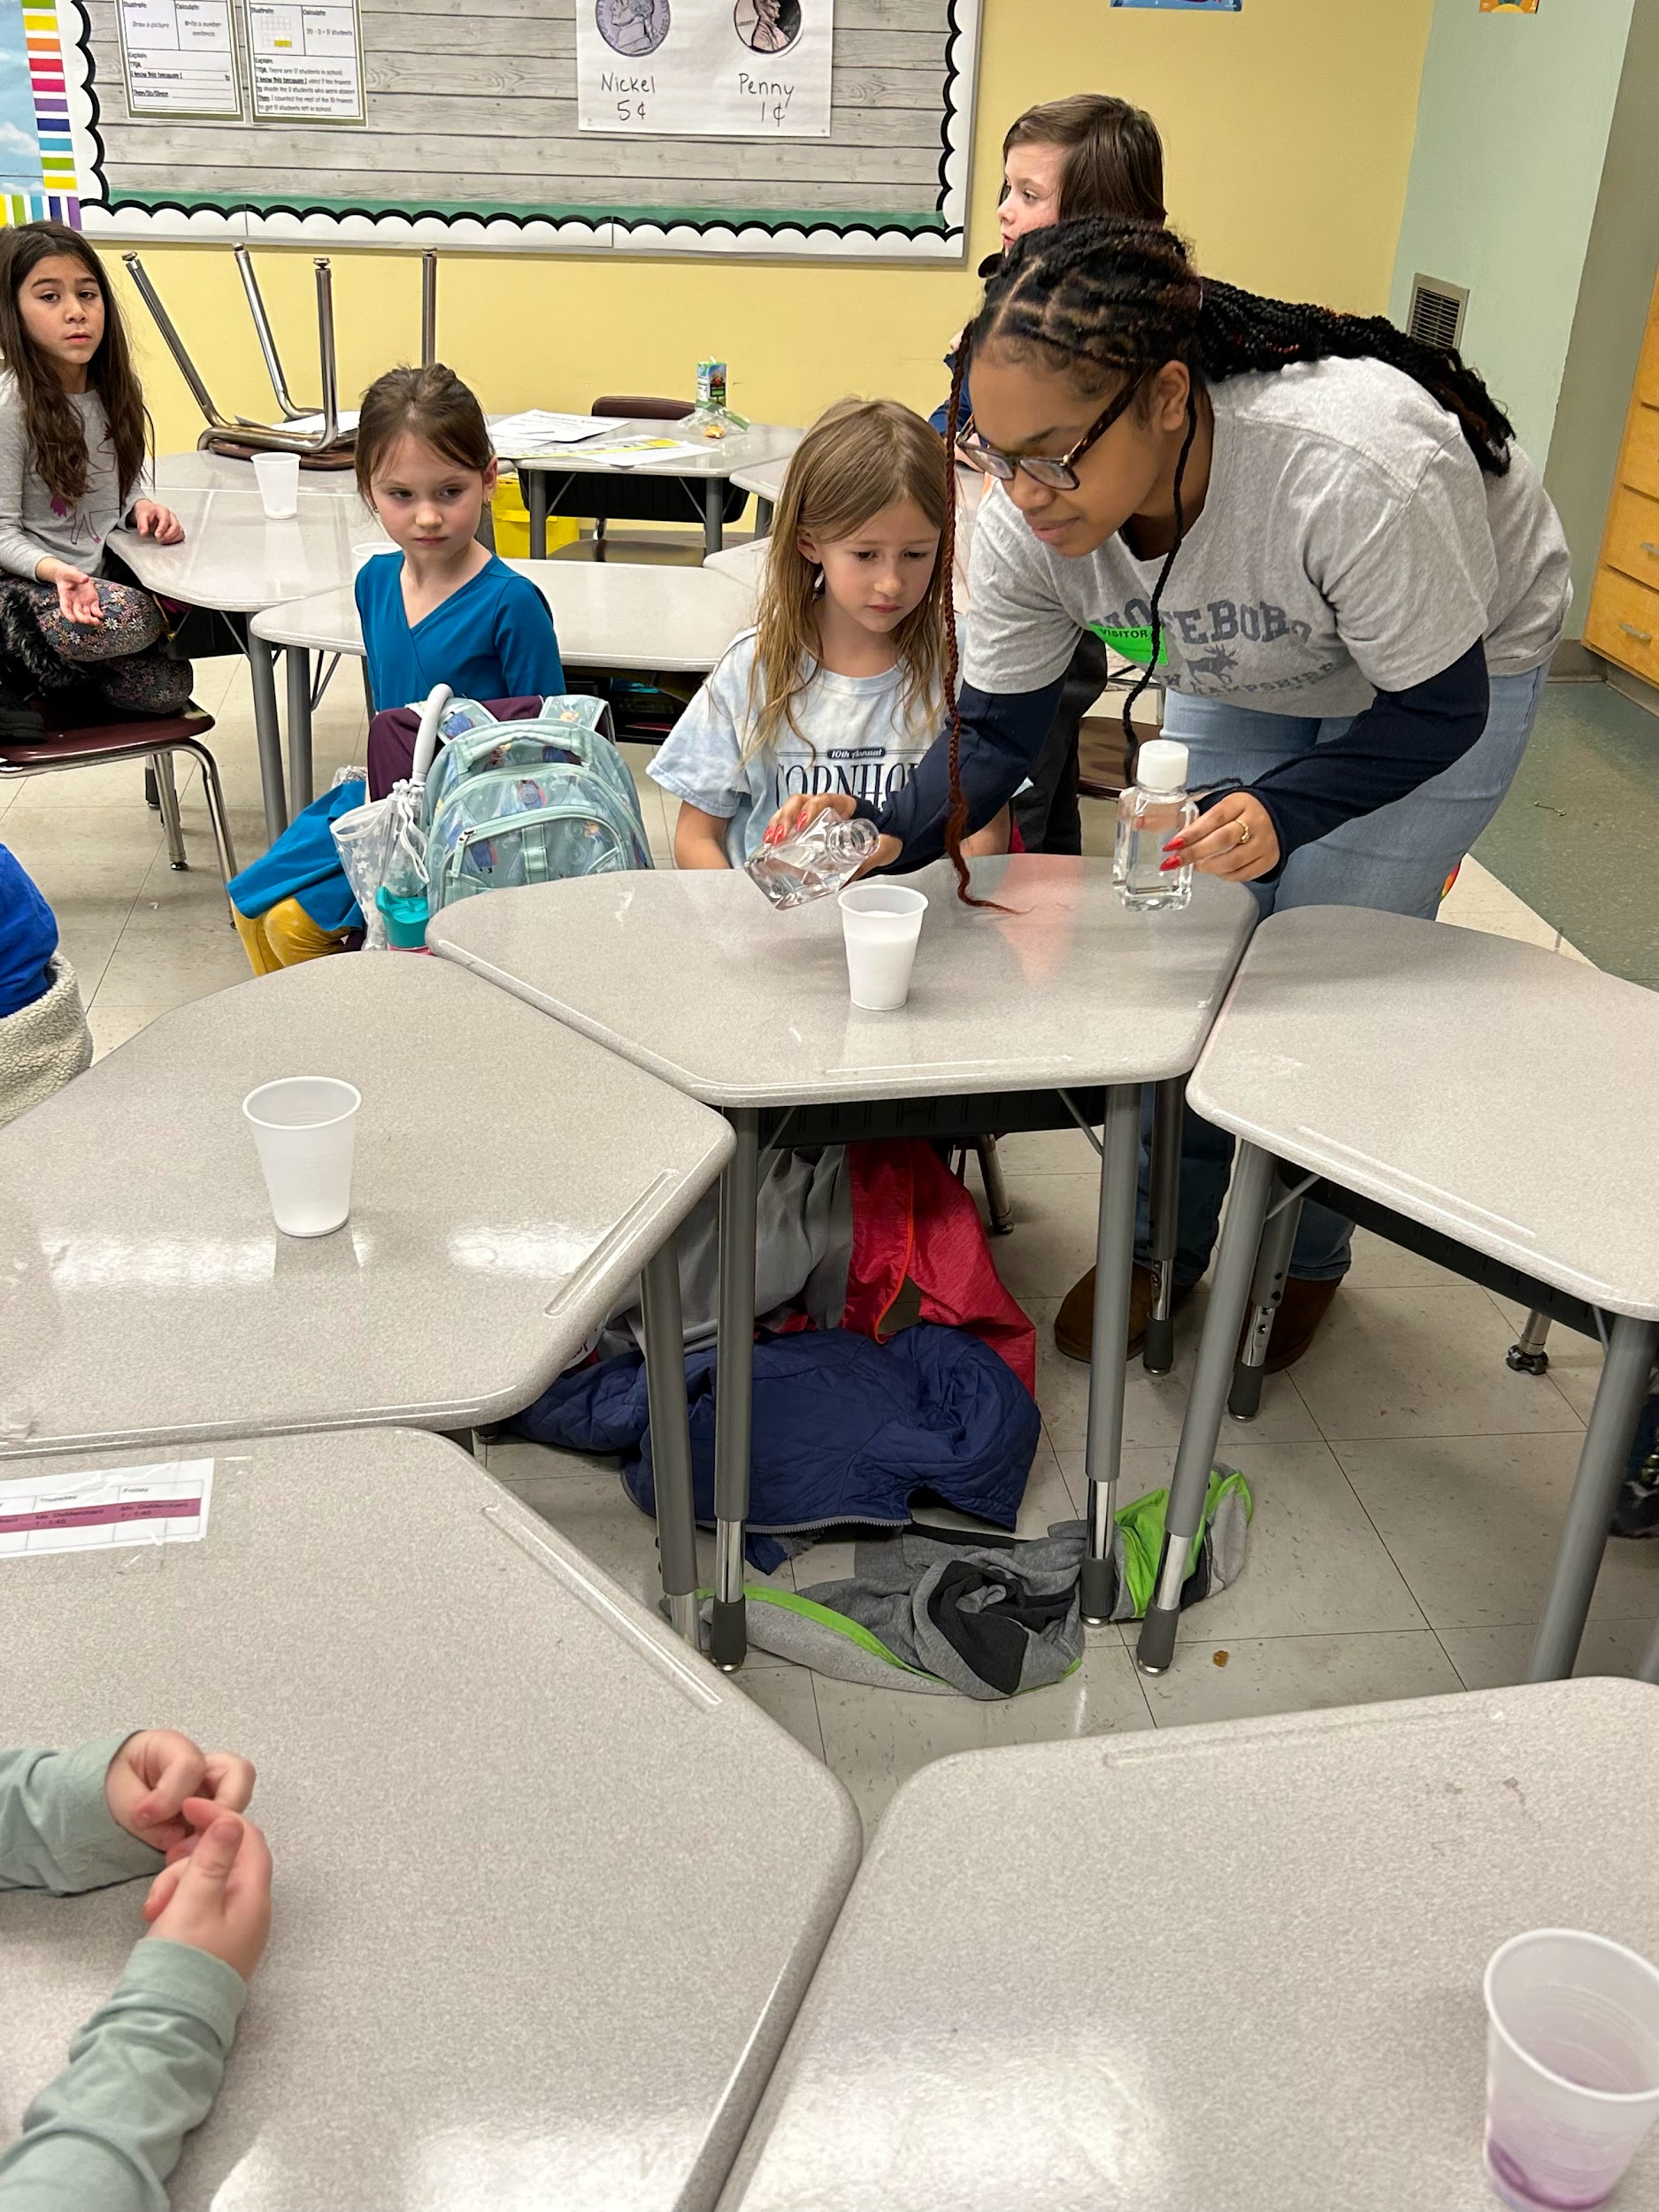
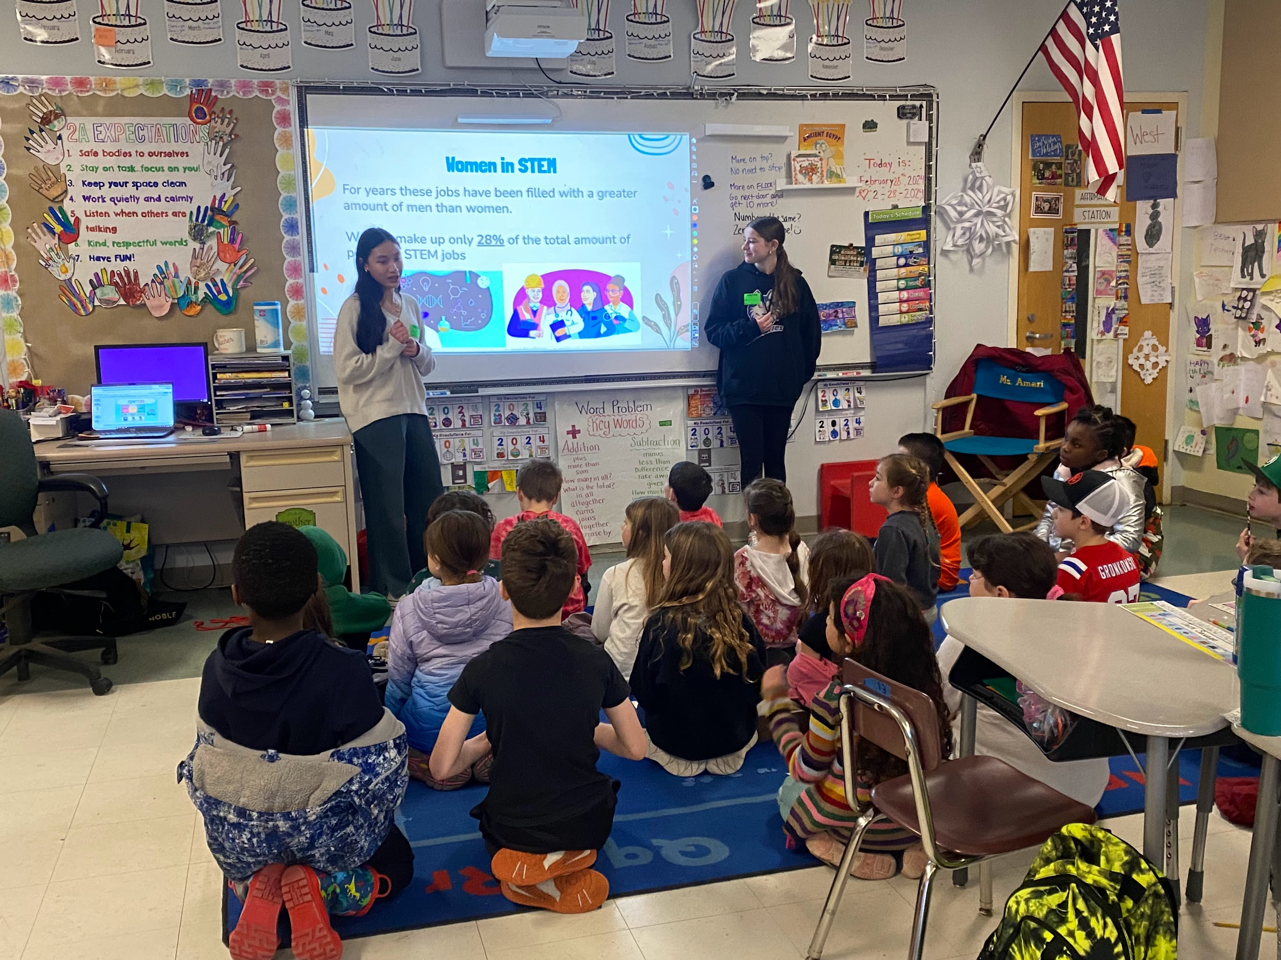

Winthrop School

The Winthrop Kindergartners have been learning so much this month! We were taught about some very famous African Americans during Black History month. We read and learned about George Crum who invented the potato chip, Michael Jordan and Jackie Robinson, famous African American athletes, Ruby Bridges, the first African American child to integrate a Southern elementary school. We also learned about Barack Obama, the first African American to be elected president of the United States.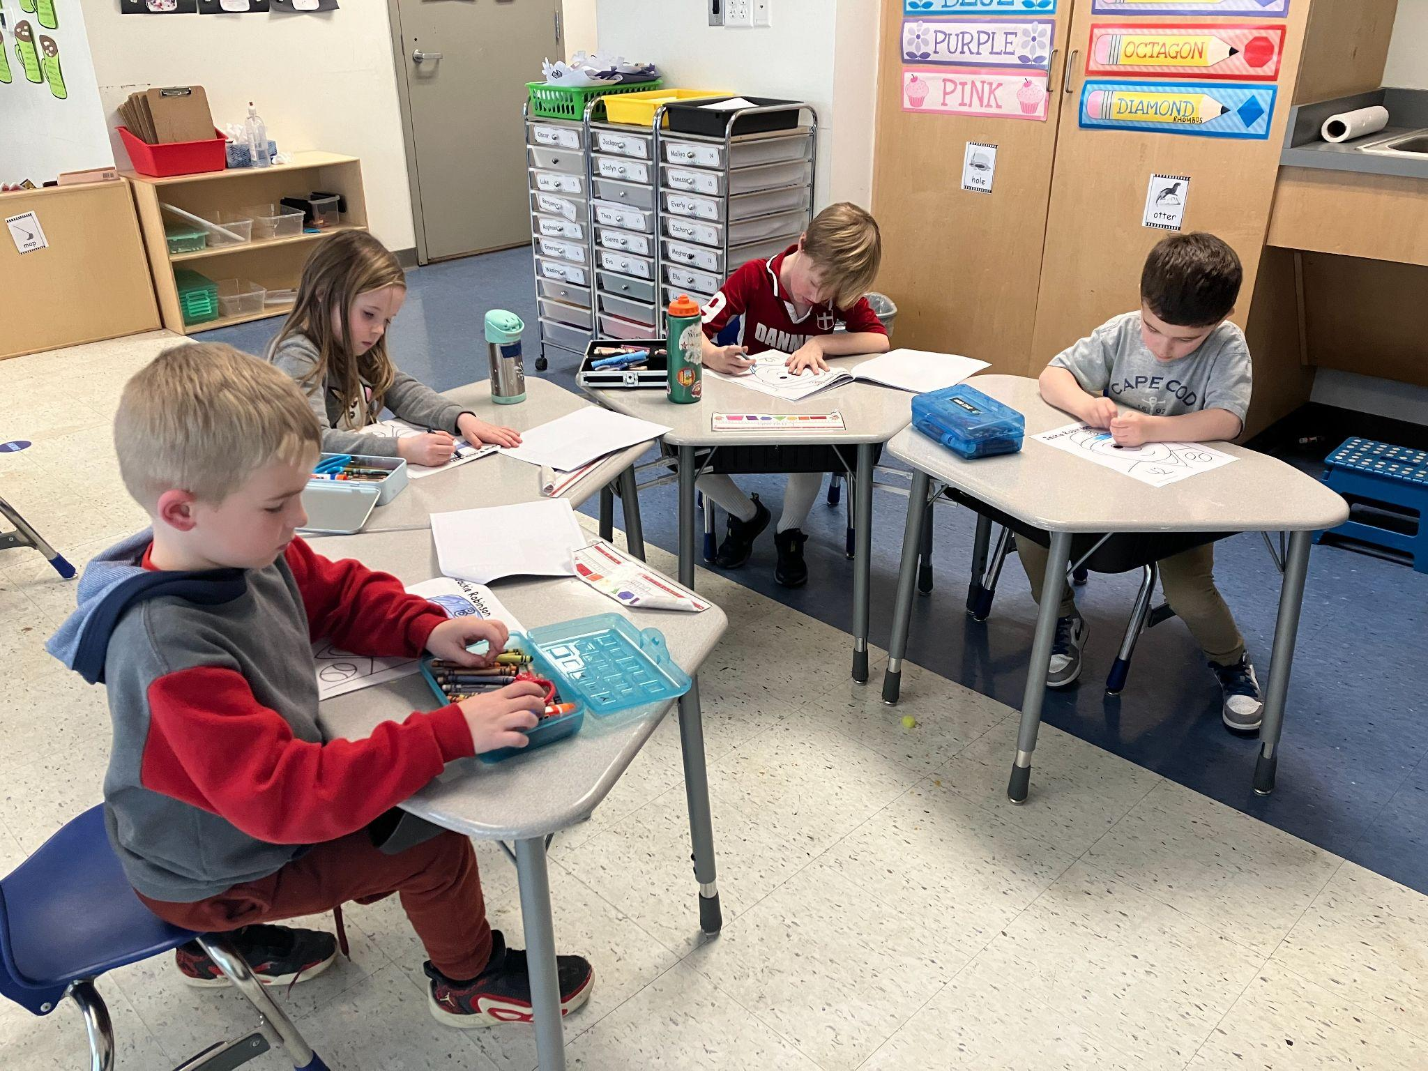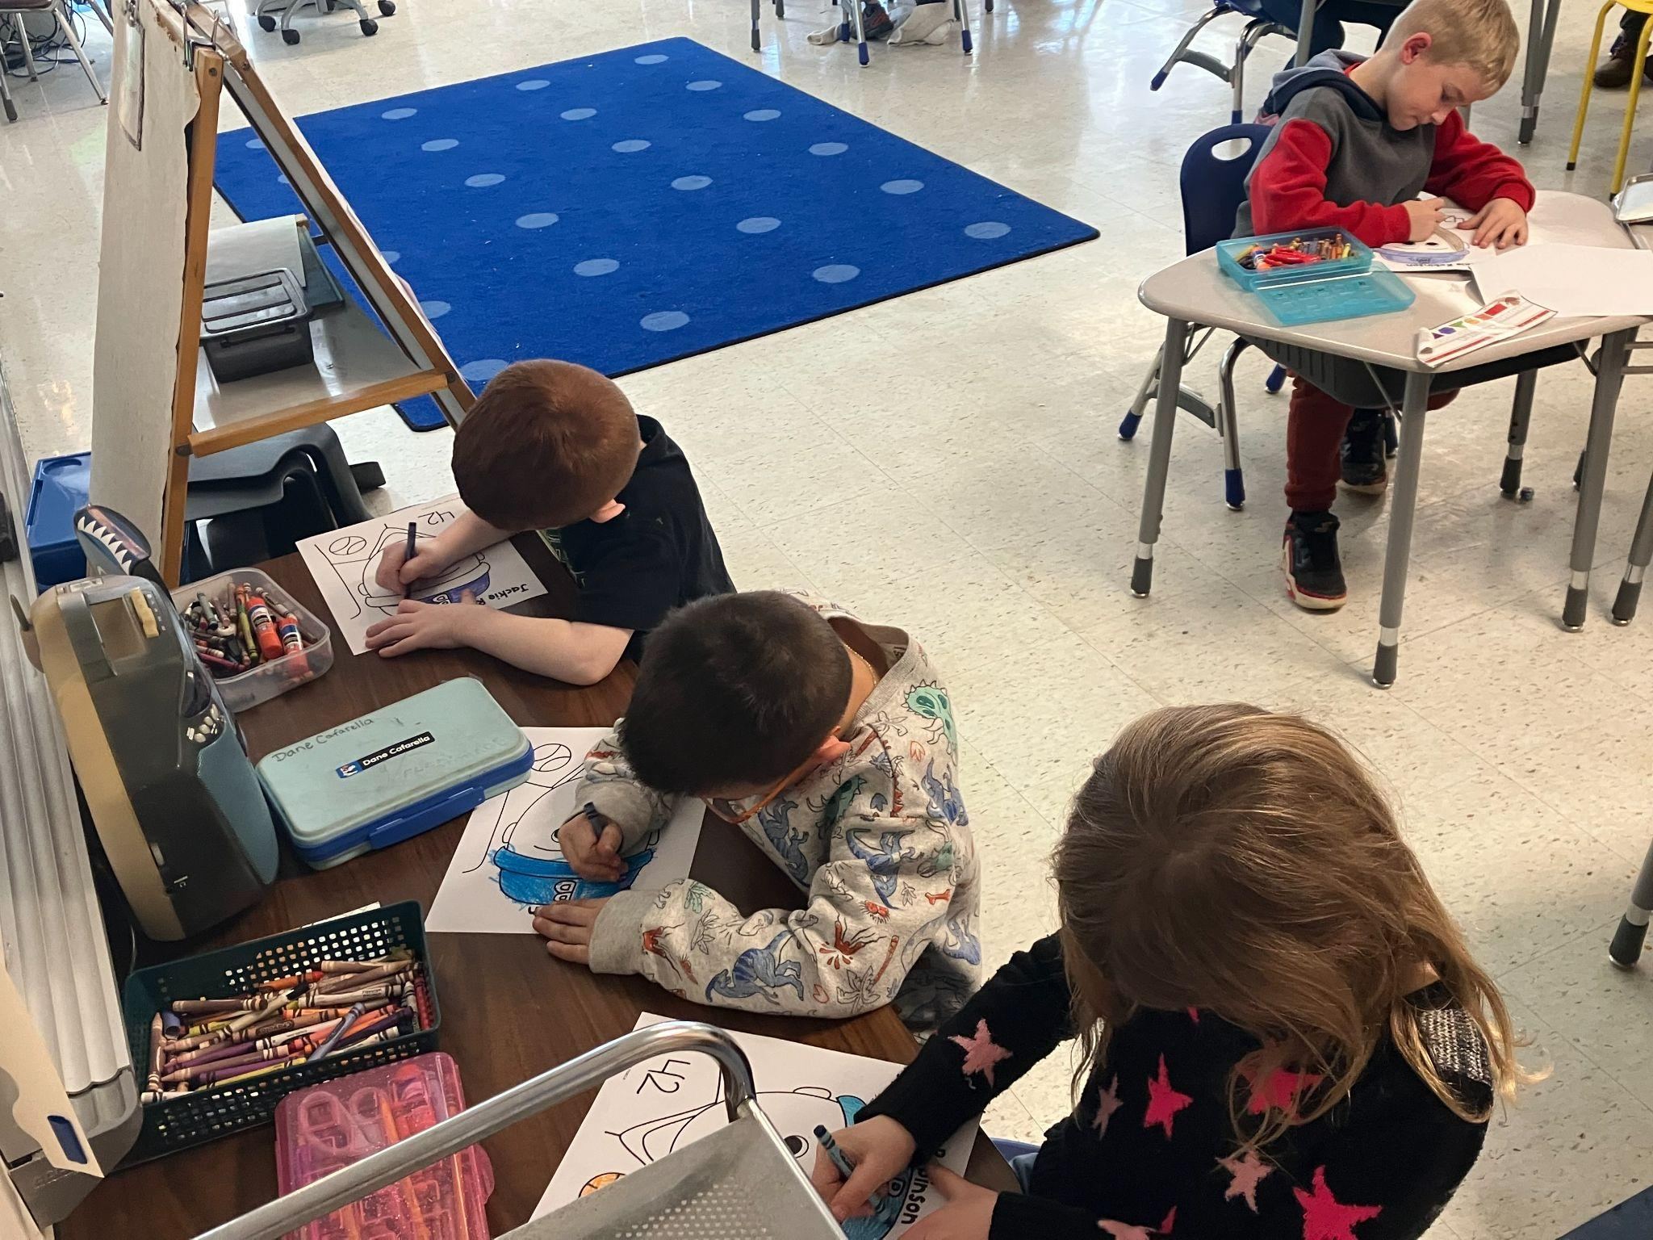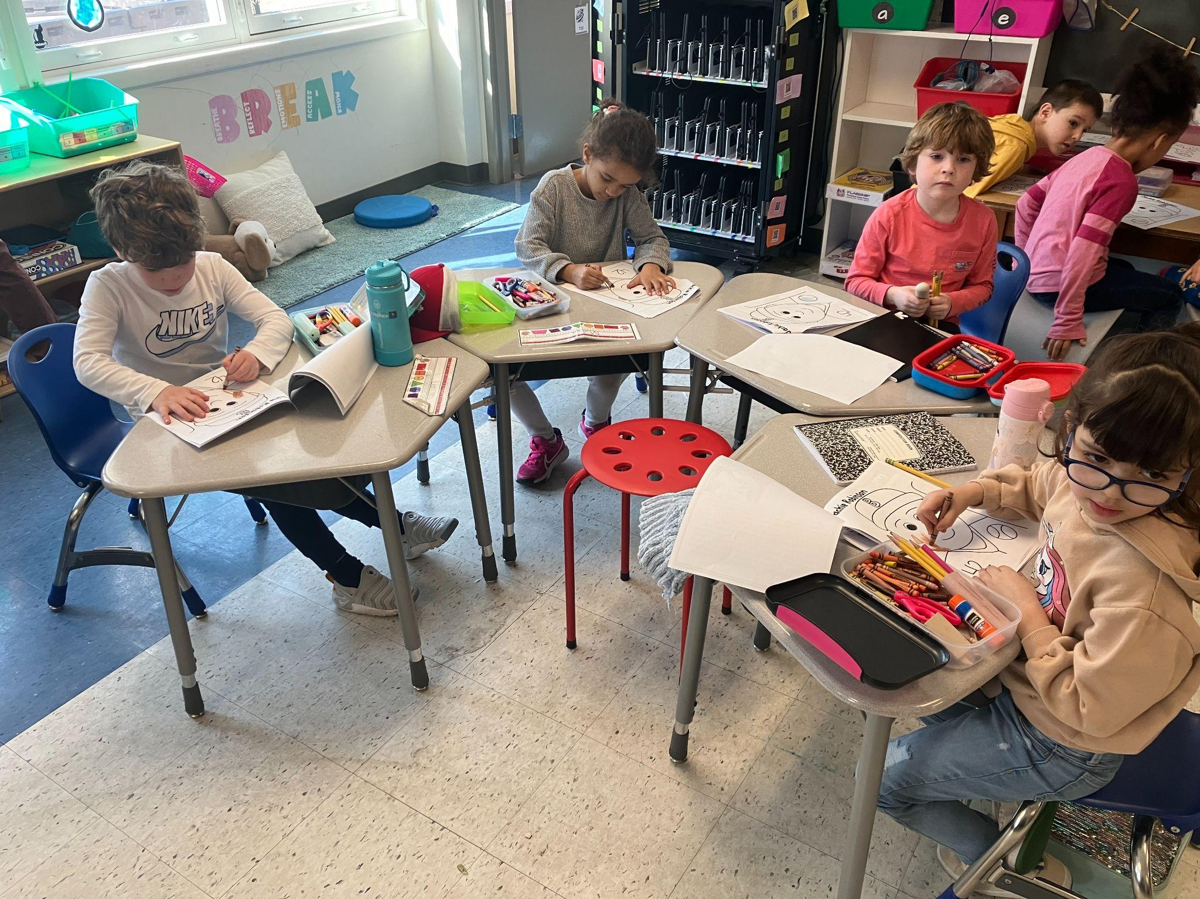

Melrose Veterans Memorial Middle School

Melrose Middle School 8th Grader, Parker Siebel, is the State Wrestling Champion for his weight class.

On Monday, our 8th Graders, started their Healthy Relationship Program which is taking place in partnership between our Wellness Classes and Melrose Alliance Against Violence (MAAV).

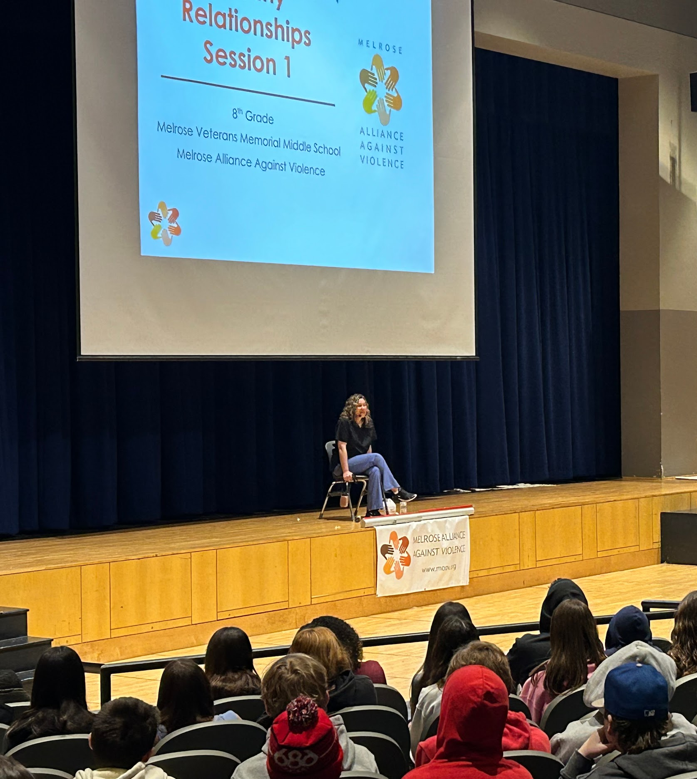

Our front entrance television is up and running with announcements for the school.

Melrose High School

Melrose High School was recently chosen as a recipient of the College Board’s AP Computer Science Female Diversity Award. 834 high schools across North America received this distinction. The College Board recognized MHS teacher, Erika Ferranti for her efforts to engage female students in AP Computer Science courses.
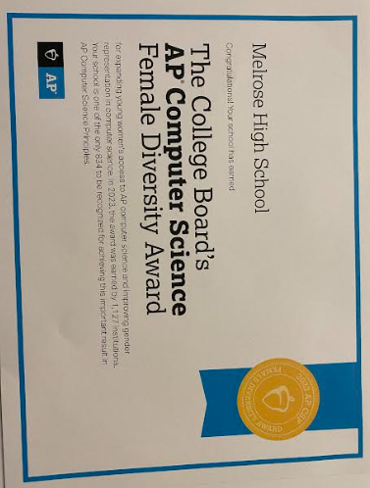

Congratulations to Wonbeaker David who will be representing Melrose at the Commonwealth of Massachusetts Semi-Finalist Poetry Out Loud competition in Newburyport, MA this Saturday.
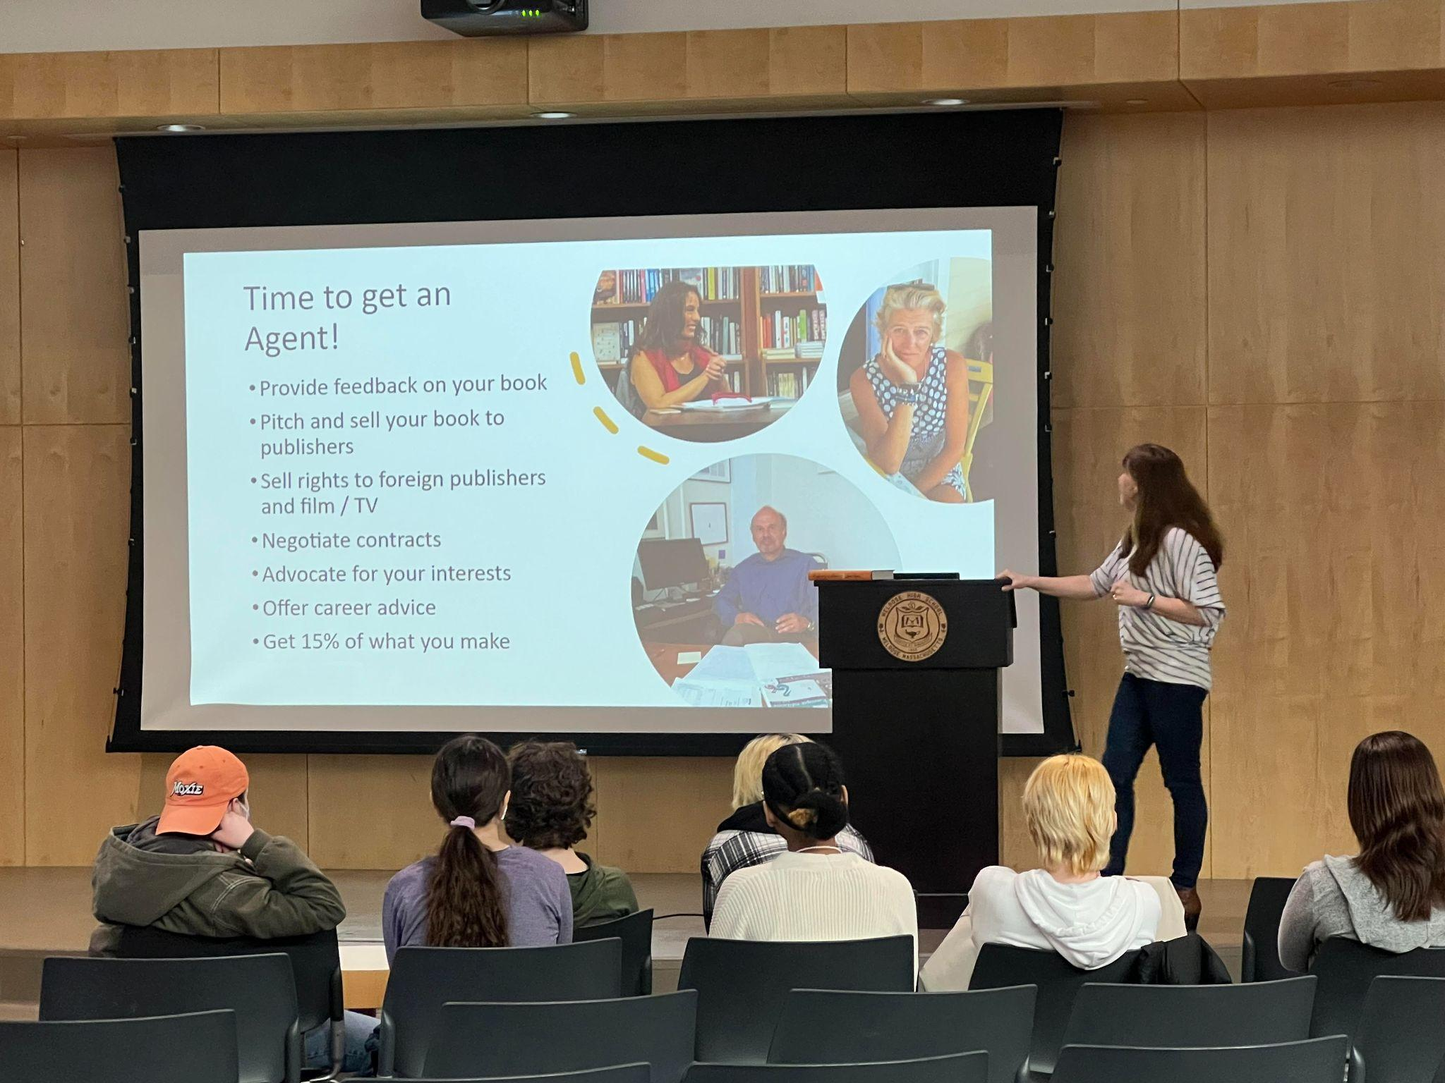
Author Jane Roper visited Ms. Severson’s Creative Writing class this week to discuss writing and the publishing process with students

Below is a picture of this year's Robot. MHS Robotics is practicing for upcoming competitions. They were hard at work throughout February vacation and have set some incredible goals this year.
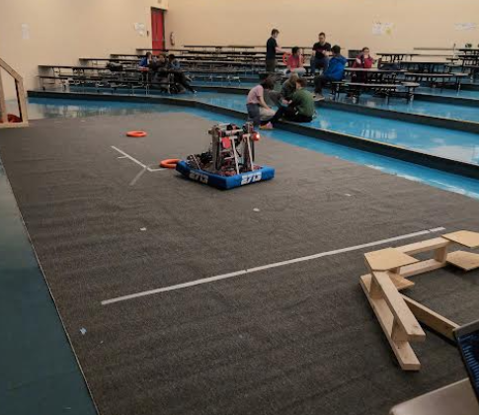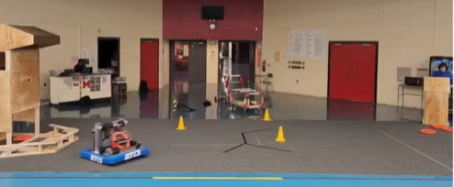

Melrose Drama presents our 2024 METG High School Festival entry: If Fortunes Be Revers'd (What Wouldst Thou Do?) -- A WORLD PREMIERE PLAY! Competing at the Andover High School Preliminary Round Saturday, March 2, 11:15 am

Written by director Tony Angeles with 6 Melrose Drama Students (Retro Bentley, Lexie Lewis, Clio Moock, Lily Polito, Lyra Rechea, and Erin Regan) this ORIGINAL PLAY is a love letter to the plays of William Shakespeare. Set in a high school in the Massachusetts town of Woham, two high school twins new to the area find a school where theater rules, and basketball and other sports are mostly forgotten.

The cast put on their annual ‘Marathon Day” performances on February 29th for our high school ELA classes throughout the school day.

