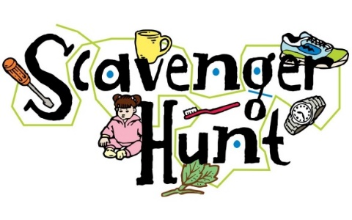

Grades: 3-5

It’s time for a little fun! Have you ever looked at a building and thought ‘What is it made of?’ or ‘Why are there so many names on those huge statues?’ Well now is your chance to find out! Check out some of the coolest spots in town and see if you can answer all of the questions in this brochure (and fill in our map)! You might even find some fun things that the adults might miss.

Good Luck & Have Fun!!

© 2021 Watertown History Museum
First Printing

1. How many buildings have porches? Label them with a ‘P’ on the map.

2. Find LeRoy Woodward and Wesley Brooks on the memorials. Which wars did they fight in? Put their initials “LW” or “WB” on the correct memorial on the map. What makes each man unique/special?

3. Where is the building where students go to learn? Draw a pencil on the correct building on the map. How is it different from where you go to learn?

4. How many buildings are made of brick? How many are made of stone? Label the buildings “B” or “S” on the map. What is the difference?
5. Where did the farmers graze their animals? Draw a farm animal on the map. **Hint: It’s not one of the boxes**

6. How many buildings have columns? Label them with a ‘C’ on the map.

7. How many churches did you find? Label them with a ‘┼’ on the map. How did you know they were churches?

8. Which building is labeled “Watertown Trust Co.”? Label map with a “$”

